***3.11 Errors.***

### *3.11.1 Customers Page Errors.*

#### 3.11.1.1 Register Form Errors.

##### 3.11.1.1.1 Customer ID must start with ‘CUS’.

If you don’t write correctly the “Customer ID” by not writing “CUS” at the beginning of the ID, it will show an error message, that says that the “Customer ID” must starts with “CUS”.

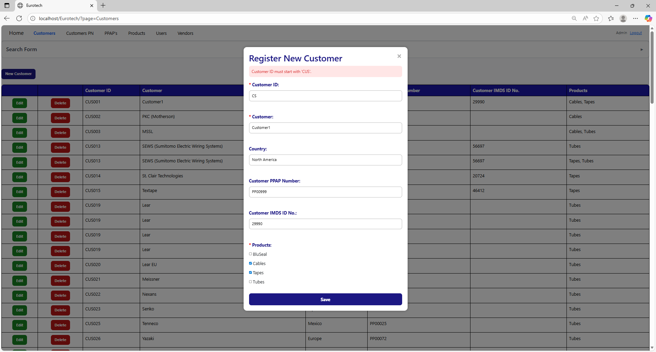

To correct this error, you must write a valid “Customer ID” following the format “CUS000” or “CUS0000”, like this example:

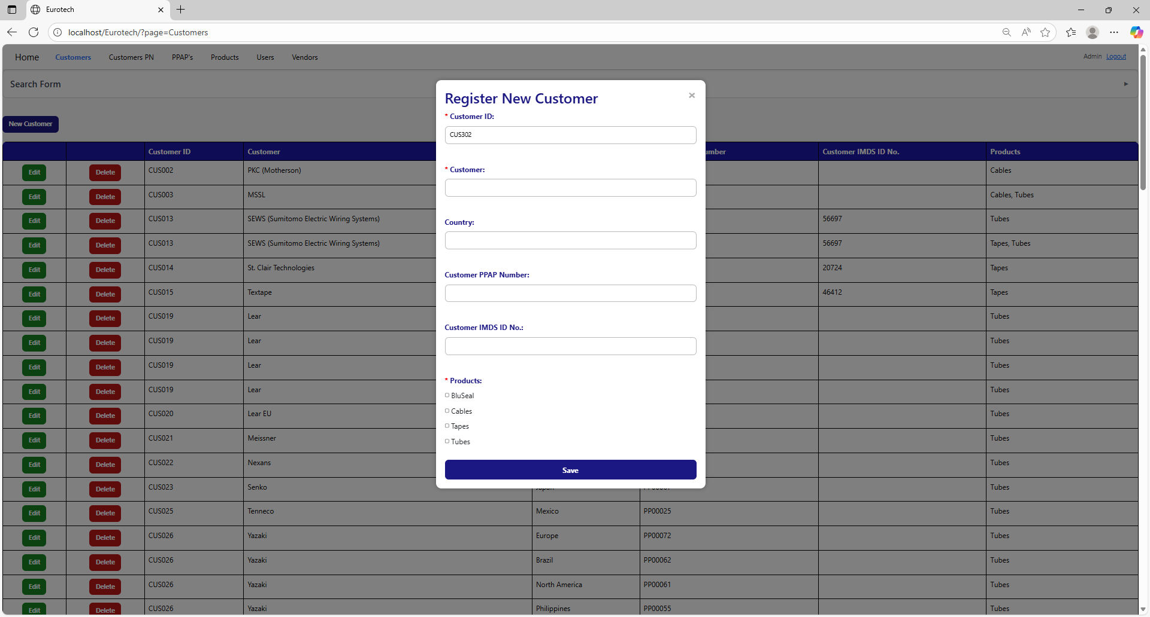

##### 3.11.1.1.2 Customer ID must contain only numbers after ‘CUS’.

If you don’t write correctly the “Customer ID” by writing no numbers after “CUS”, it will show an error message, that says that the “Customer ID” must contain only numbers after “CUS”.

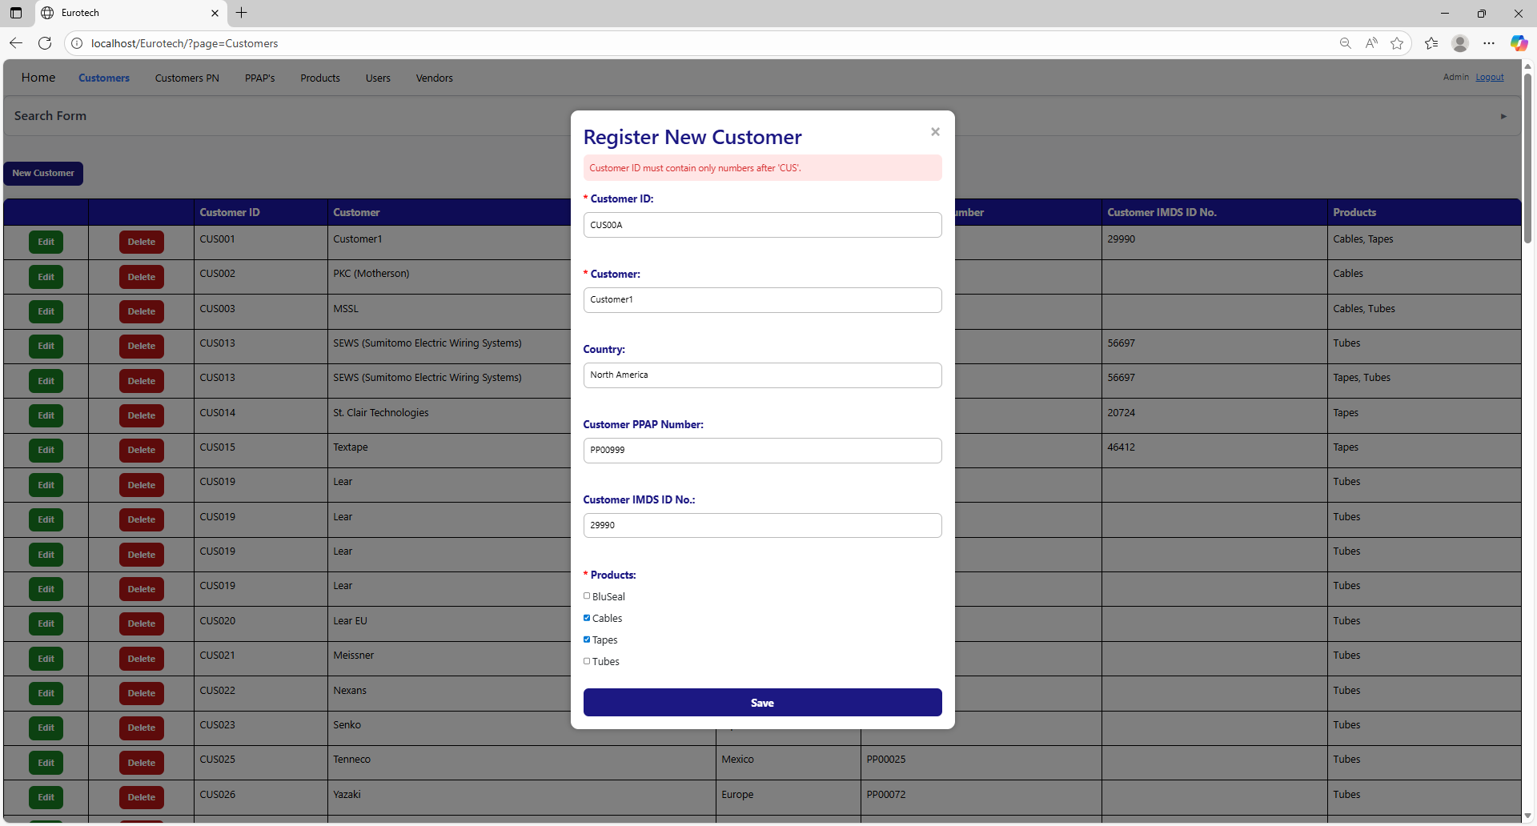

To correct this error, you must write a valid “Customer ID” following the format “CUS000” or “CUS0000”, like this example:



##### 3.11.1.1.3 The customer *name of the customer* - *country* already exists.

If you write in the fields “Customer” and “Country” the data of a customer that already exists, it will show an error message, that says that already exists a register with the customer’s name and country you are trying to register.

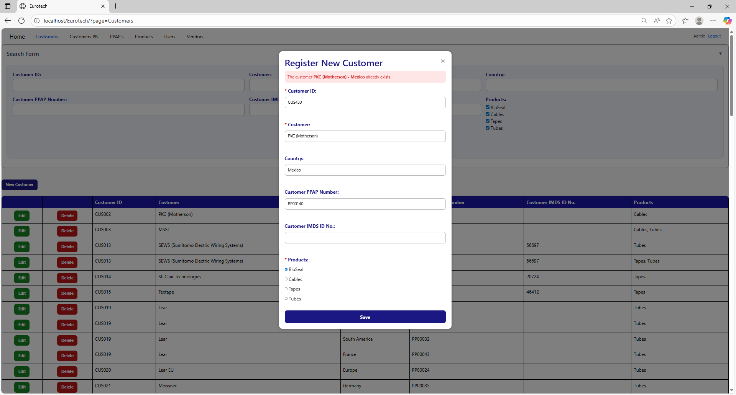

The error message prevents duplicate registers of customers.

##### 3.11.1.1.4 The customer *name of the customer* already exists.

If you write in the “Customer” field and the “Country” field is empty, and this data match with a customer that already exists, it will show an error message, that says that already exists a register with the customer’s name you are trying to register.

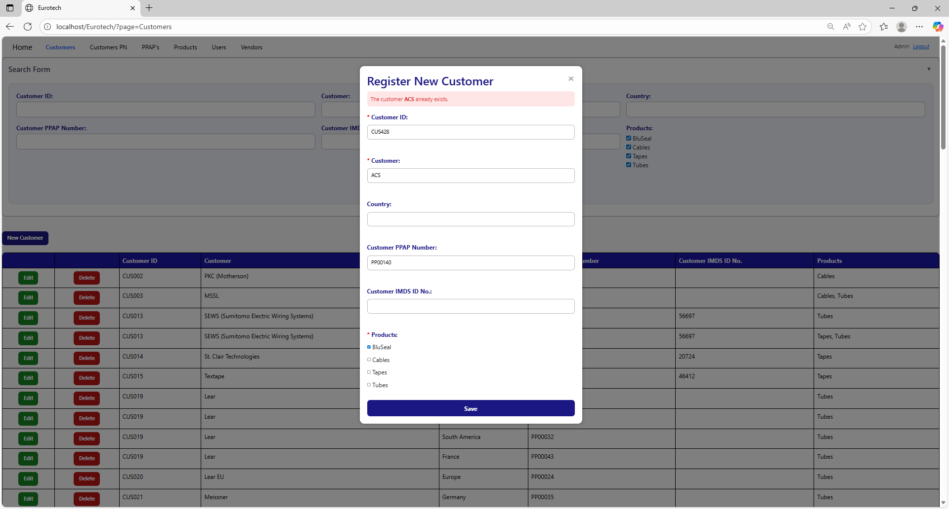

The error message prevents duplicate registers of customers.

##### 3.11.1.1.5 Customer PPAP Number must have the form 'PP00000'.

If you don’t write correctly the “Customer PPAP Number” by not writing “PP” at the beginning or by not writing numbers after “PP”, it will show an error message, that says that the “Customer PPAP Number” must have the form “PP00000”.

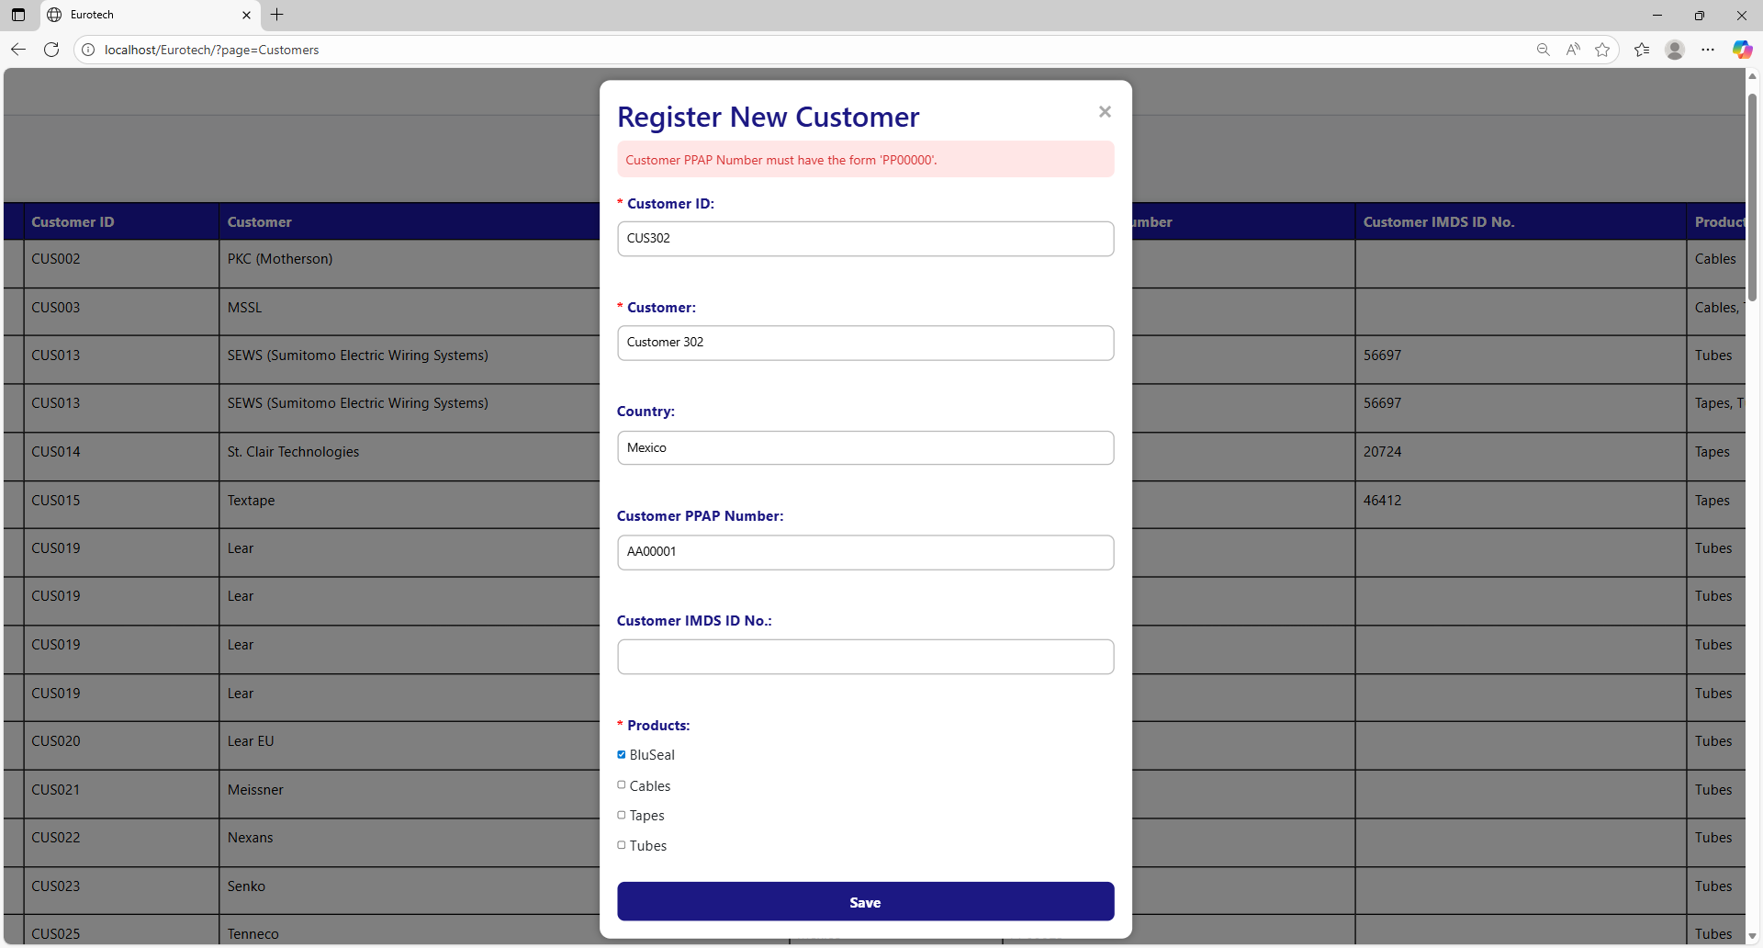

To correct this error, you must write a valid “Customer PPAP Number” following the format “PP00000”, like this example:

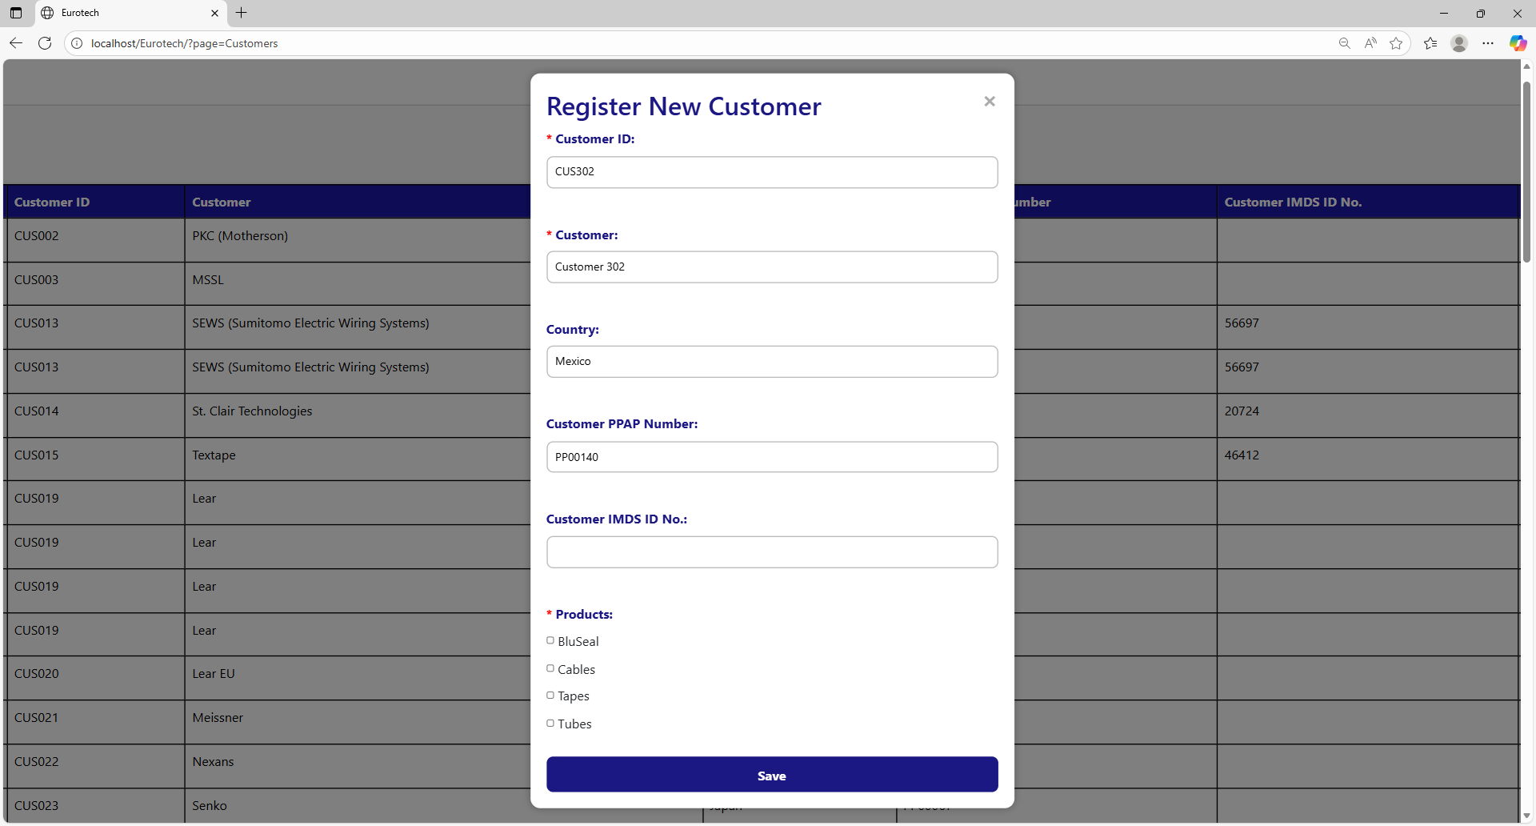

##### 3.11.1.1.6 The Customer PPAP Number *Customer PPAP Number* already exists.

If you write in the “Customer PPAP Number” field a PPAP Number that already exists, it will show an error message, that says that already exists a register with the Customer PPAP Number you are trying to register.

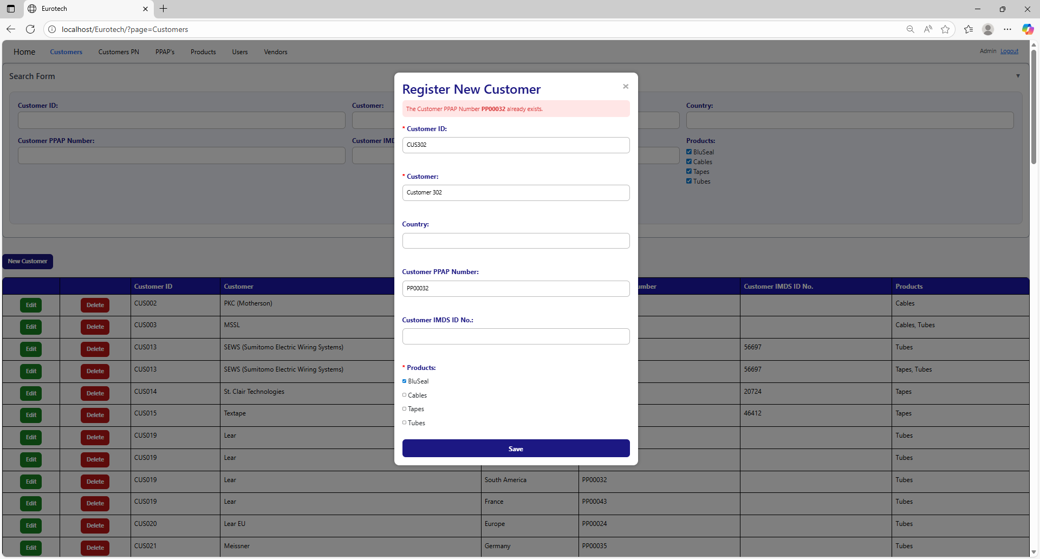

To correct this error, you must write a “Customer PPAP Number” that doesn’t exist.

##### 3.11.1.1.7 You must select at least 1 product for the customer.

If you don’t select at least 1 product in the “Product” field, it will show an error message, that says that you must select at least 1 product for the customer.

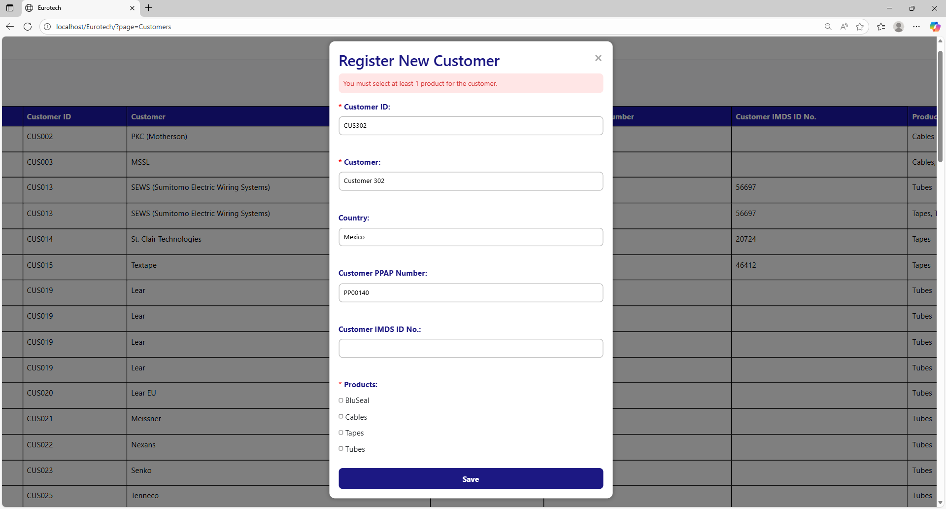

To correct this error, you must select at least 1 product for the customer, like this example:

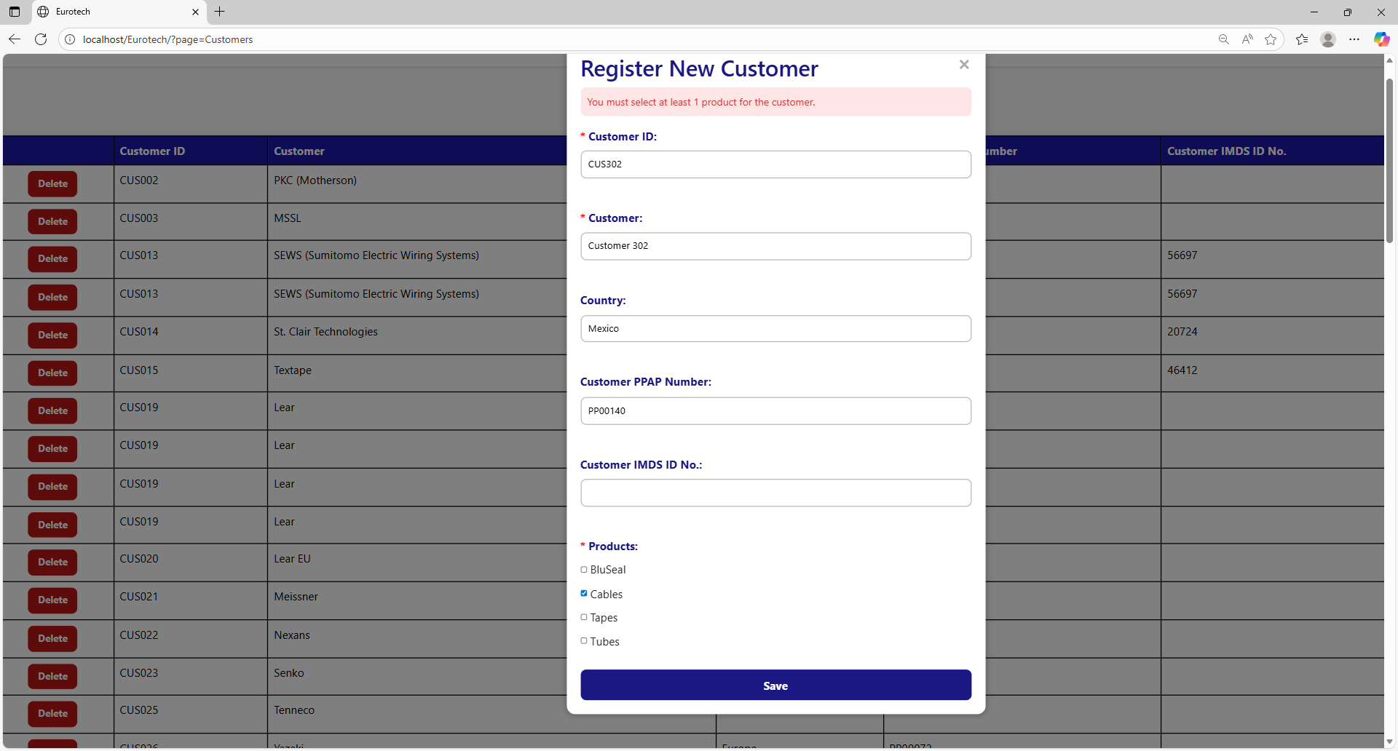

#### 3.11.1.2 Edit Form Errors.

##### 3.11.1.2.1 Customer ID must start with ‘CUS’.

If you don’t write correctly the “Customer ID” by not writing “CUS” at the beginning of the ID, it will show an error message, that says that the “Customer ID” must starts with “CUS”.

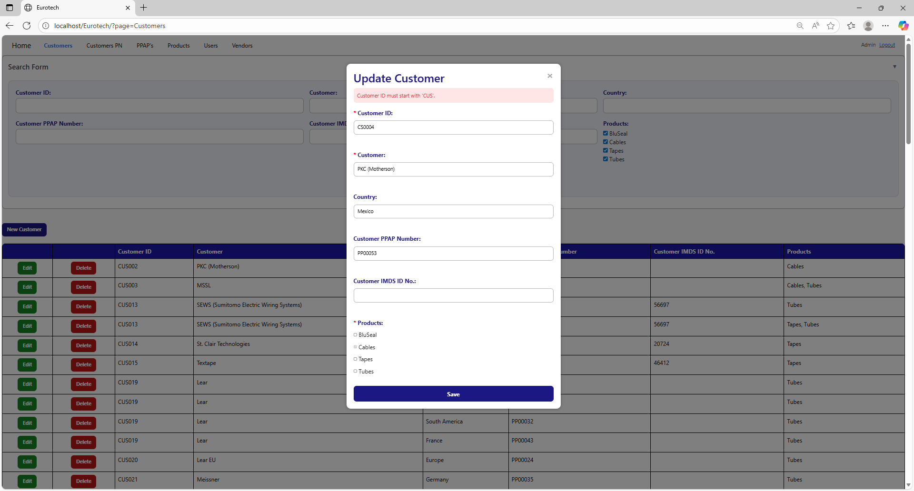

To correct this error, you must write a valid “Customer ID” following the format “CUS000” or “CUS0000”, like this example:

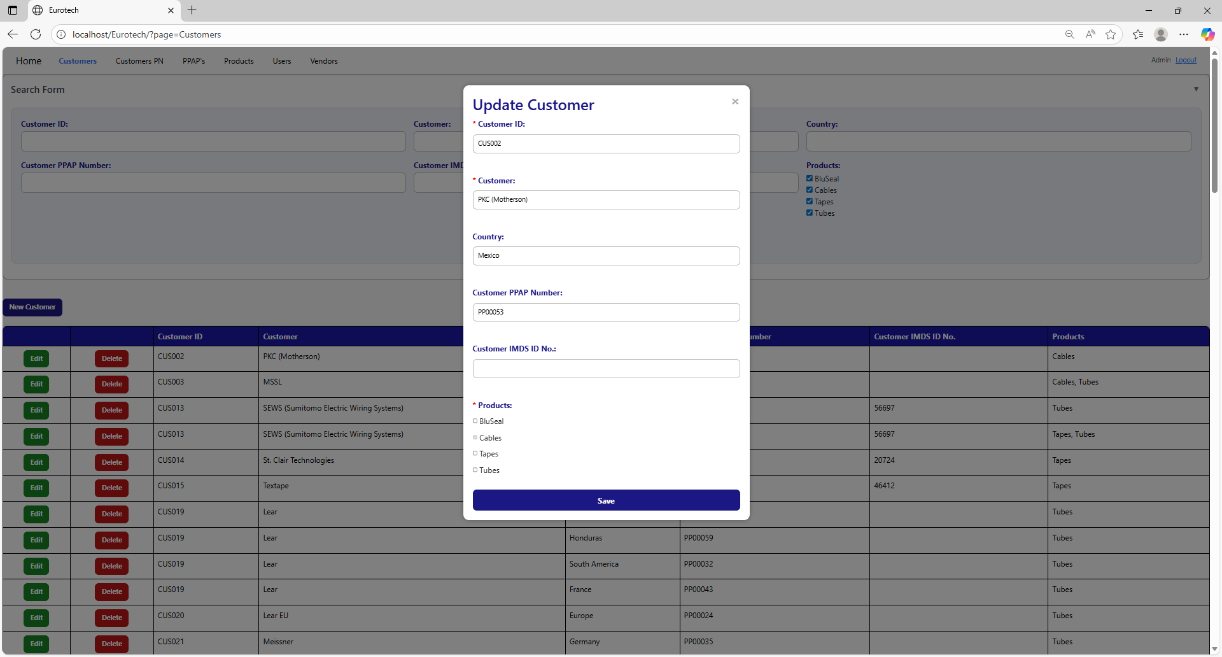

##### 3.11.1.2.2 Customer ID must contain only numbers after ‘CUS’.

If you don’t write correctly the “Customer ID” by writing no numbers after “CUS”, it will show an error message, that says that the “Customer ID” must contain only numbers after “CUS”.

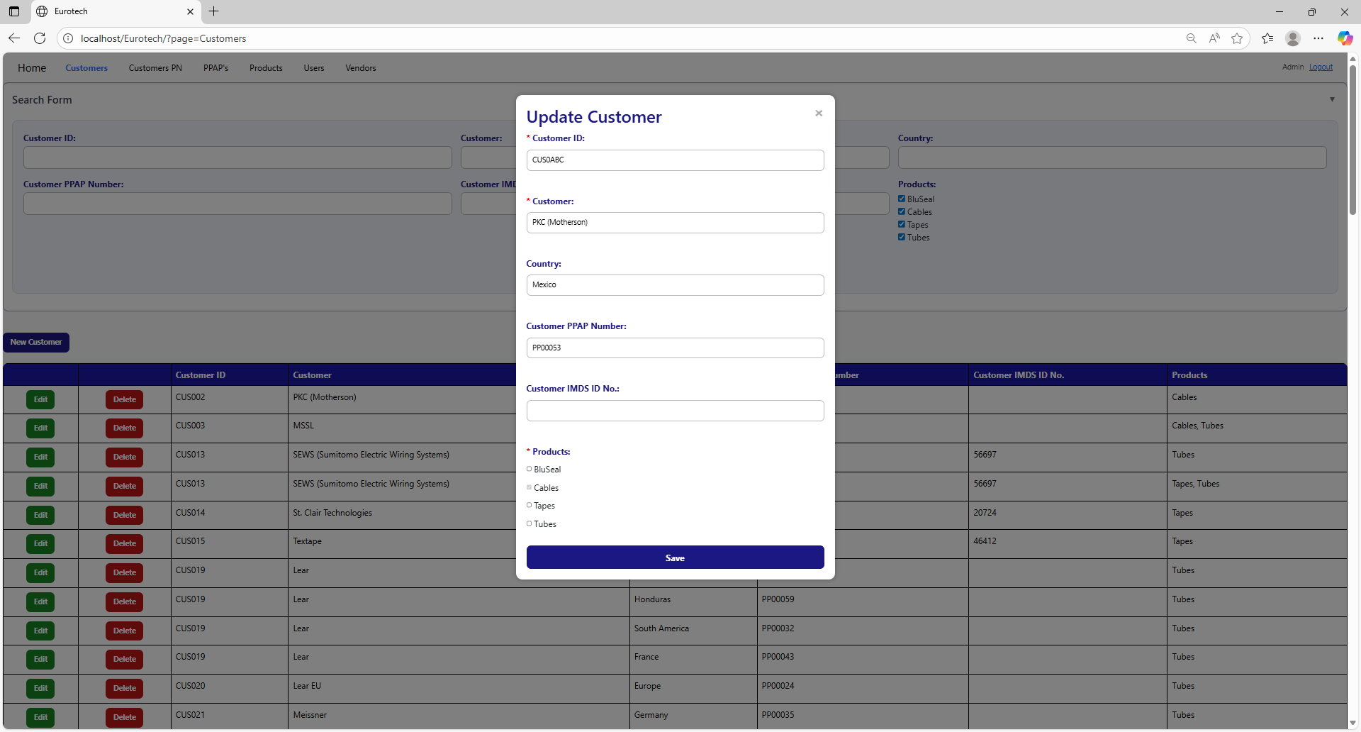

To correct this error, you must write a valid “Customer ID” following the format “CUS000” or “CUS0000”, like this example:



##### 3.11.1.2.3 The customer *name of the customer* - *country* already exists.

If you write in the fields “Customer” and “Country” the data of a customer that already exists, it will show an error message, that says that already exists a register with the customer’s name and country you are trying to register.

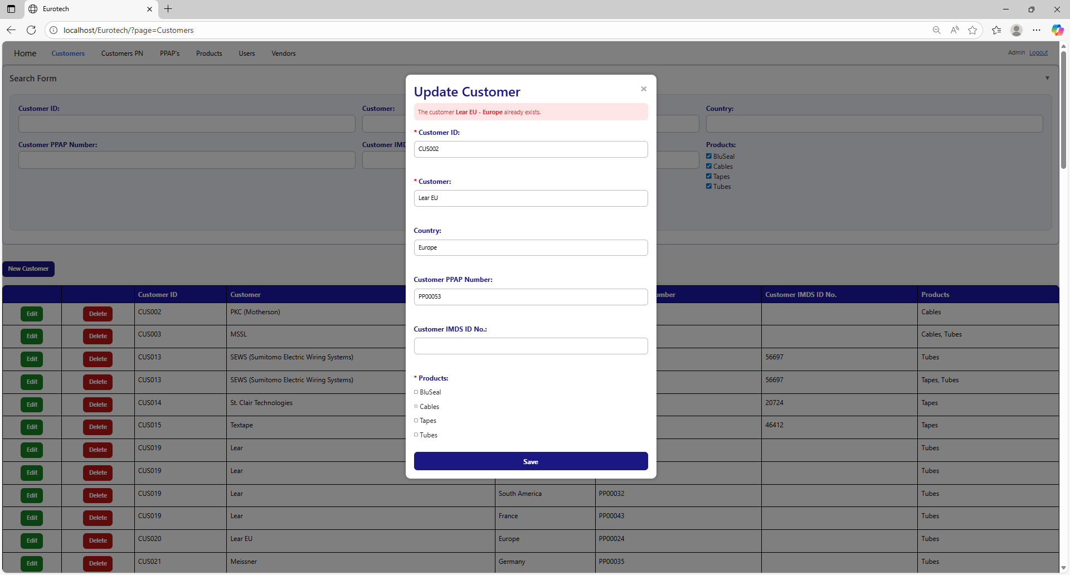

The error message prevents duplicate registers of customers.

##### 3.11.1.2.4 The customer *name of the customer* already exists.

If you write in the “Customer” field and the “Country” field is empty, and this data match with a customer that already exists, it will show an error message, that says that already exists a register with the customer’s name you are trying to register.

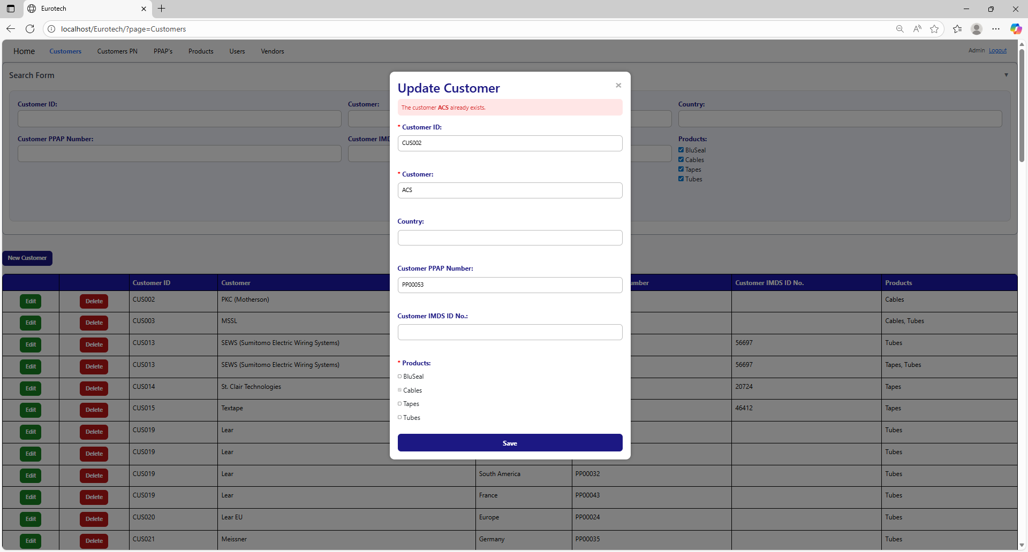

The error message prevents duplicate registers of customers.

##### 3.11.1.2.5 Customer PPAP Number must have the form 'PP00000'.

If you don’t write correctly the “Customer PPAP Number” by not writing “PP” at the beginning or by not writing numbers after “PP”, it will show an error message, that says that the “Customer PPAP Number” must have the form “PP00000”.

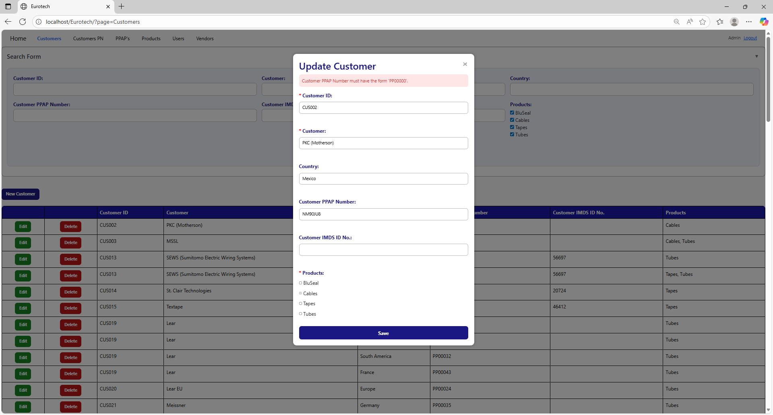

To correct this error, you must write a valid “Customer PPAP Number” following the format “PP00000”, like this example:



##### 3.11.1.2.6 The Customer PPAP Number *PPAP Number* already exists.

If you write in the “Customer PPAP Number” field a PPAP Number that already exists, it will show an error message, that says that already exists a register with the Customer PPAP Number you are trying to register.

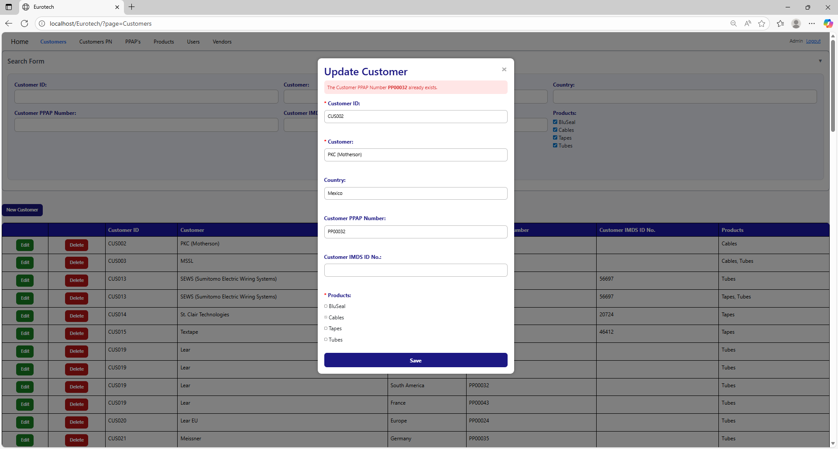

To correct this error, you must write a “Customer PPAP Number” that doesn’t exist.

#### 3.11.1.3 Delete Form Errors.

##### 3.11.1.3.1 This customer can't be deleted, because it already has registers.

If you tried to delete a customer, and it shows you an error message, that says that the customer you are trying to delete can’t be deleted, because it already has registers, this means that the customer has registers in the “Customers PN” page and probably in the “PPAP’s” page.

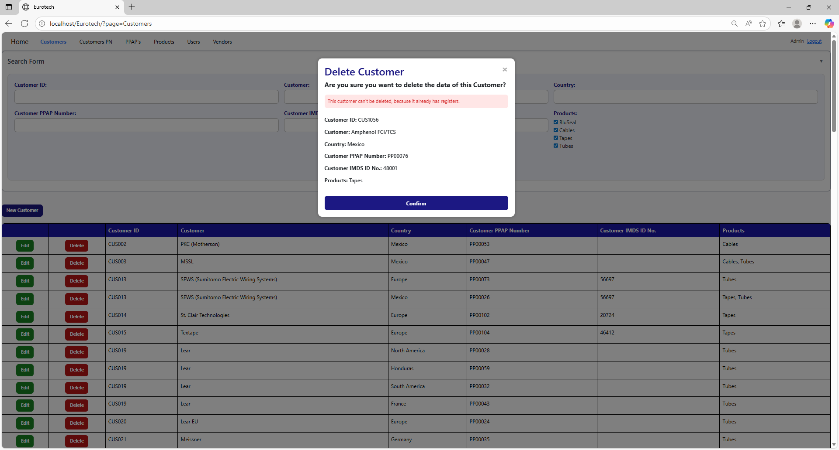

If you want to delete the customer, you must delete all the registers of this customer in the pages “Customers PN” and “PPAP’s”.

### *3.11.2 Customers PN Page Errors.*

#### 3.11.2.1 Register Form Errors.

##### 3.11.2.1.1 The customer *name of the customer* - *country* doesn’t exist.

If you write in the fields “Customer” and “Country” the data of a customer that doesn’t exist, it will show an error message, that says that doesn’t exist a register with the customer’s name and country you are trying to register.

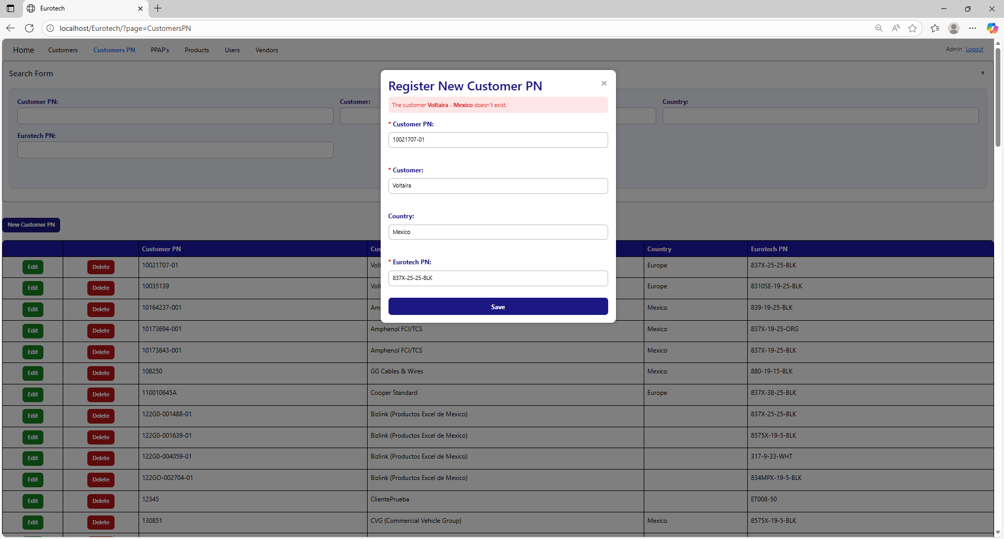

To correct this error, you must check first if the “Customer” and “Country” are written correctly. If they are written correctly but it keeps showing the same error message, then you must check in the “Customers” page if the register of the customer exists **(you can check in the Index the instruction *3.1.2 How to Search a Customer*).**

If the customer is not in the registers of the “Customers” page, then you must create a new register for that customer **(you can check in the Index the instruction *3.1.3 How to Add a New Customer*).**

Once you create the customer, you can now try to register the new Customer PN again.

##### 3.11.2.1.2 The customer *name of the customer* doesn’t exist.

If you write in the “Customer” field and the “Country” field is empty, and the data doesn’t match with a register of a customer, it will show an error message, that says that doesn’t exist a register with the customer’s name you are trying to register.

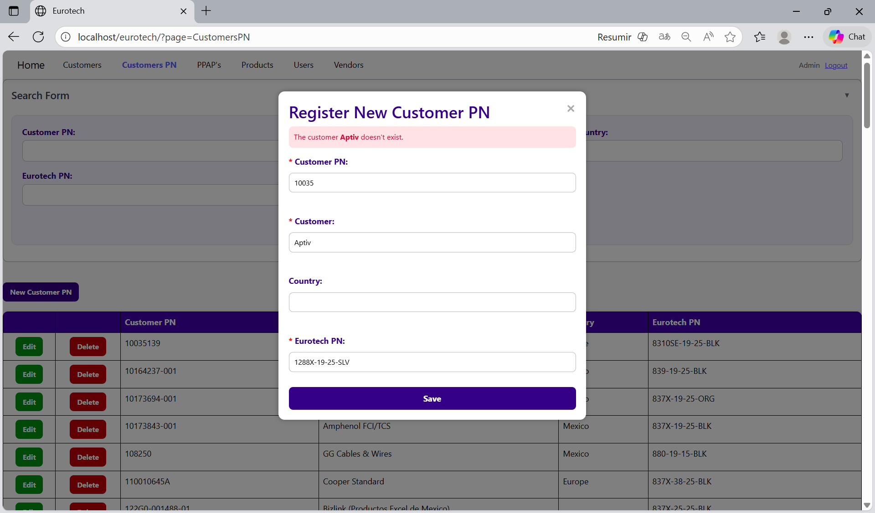

To correct this error, you must check first if the “Customer” is written correctly. If it is written correctly but it keeps showing the same error message, then you must check in the “Customers” page if the register of the customer exists **(you can check in the Index the instruction *3.1.2 How to Search a Customer*).**

If the customer is not in the registers of the “Customers” page, then you must create a new register for that customer **(you can check in the Index the instruction *3.1.3 How to Add a New Customer*).**

Once you create the customer, you can now try to register the new Customer PN again.

##### 3.11.2.1.3 The Eurotech PN *Eurotech PN* doesn't exist.

If you write in the “Eurotech PN” field and the data doesn’t match with a register of a product of Eurotech, it will show an error message, that says that doesn’t exist a register with the Eurotech PN you are trying to register.

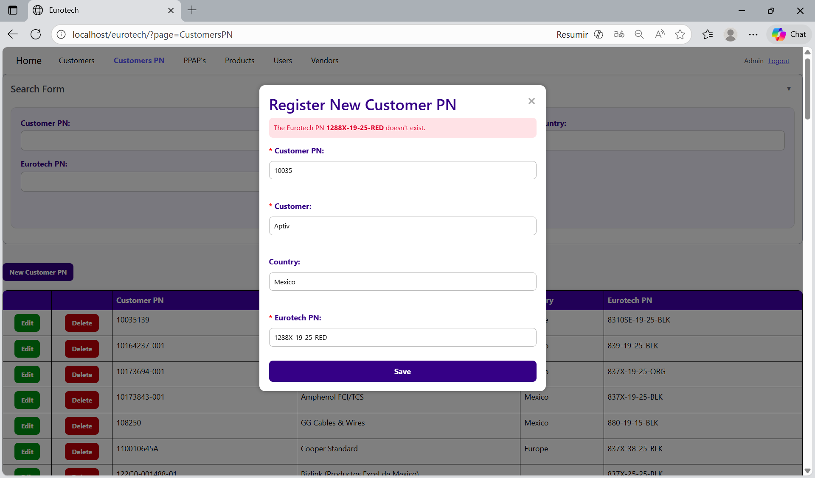

To correct this error, you must check first if the “Eurotech PN” is written correctly. If it is written correctly but it keeps showing the same error message, then you must check in the “Products” page if the register of the product exists **(you can check in the Index the instruction *3.8.2 How to Search a Product*).**

If the product is not in the registers of the “Products” page, then you must create a new register for that product **(you can check in the Index the instruction *3.8.3 How to Add a New Product*).**

Once you create the product, you can now try to register the new Customer PN again.

##### 3.11.2.1.4 A Customer PN already exists for the Eurotech PN *Eurotech PN* and the customer *name of the customer* - *country*.

If you try to duplicate a register with the same “Customer”, “Country” and “Eurotech PN”, it will show an error message, that says that a Customer PN already exists for the Eurotech PN, customer’s name and country you are trying to register.

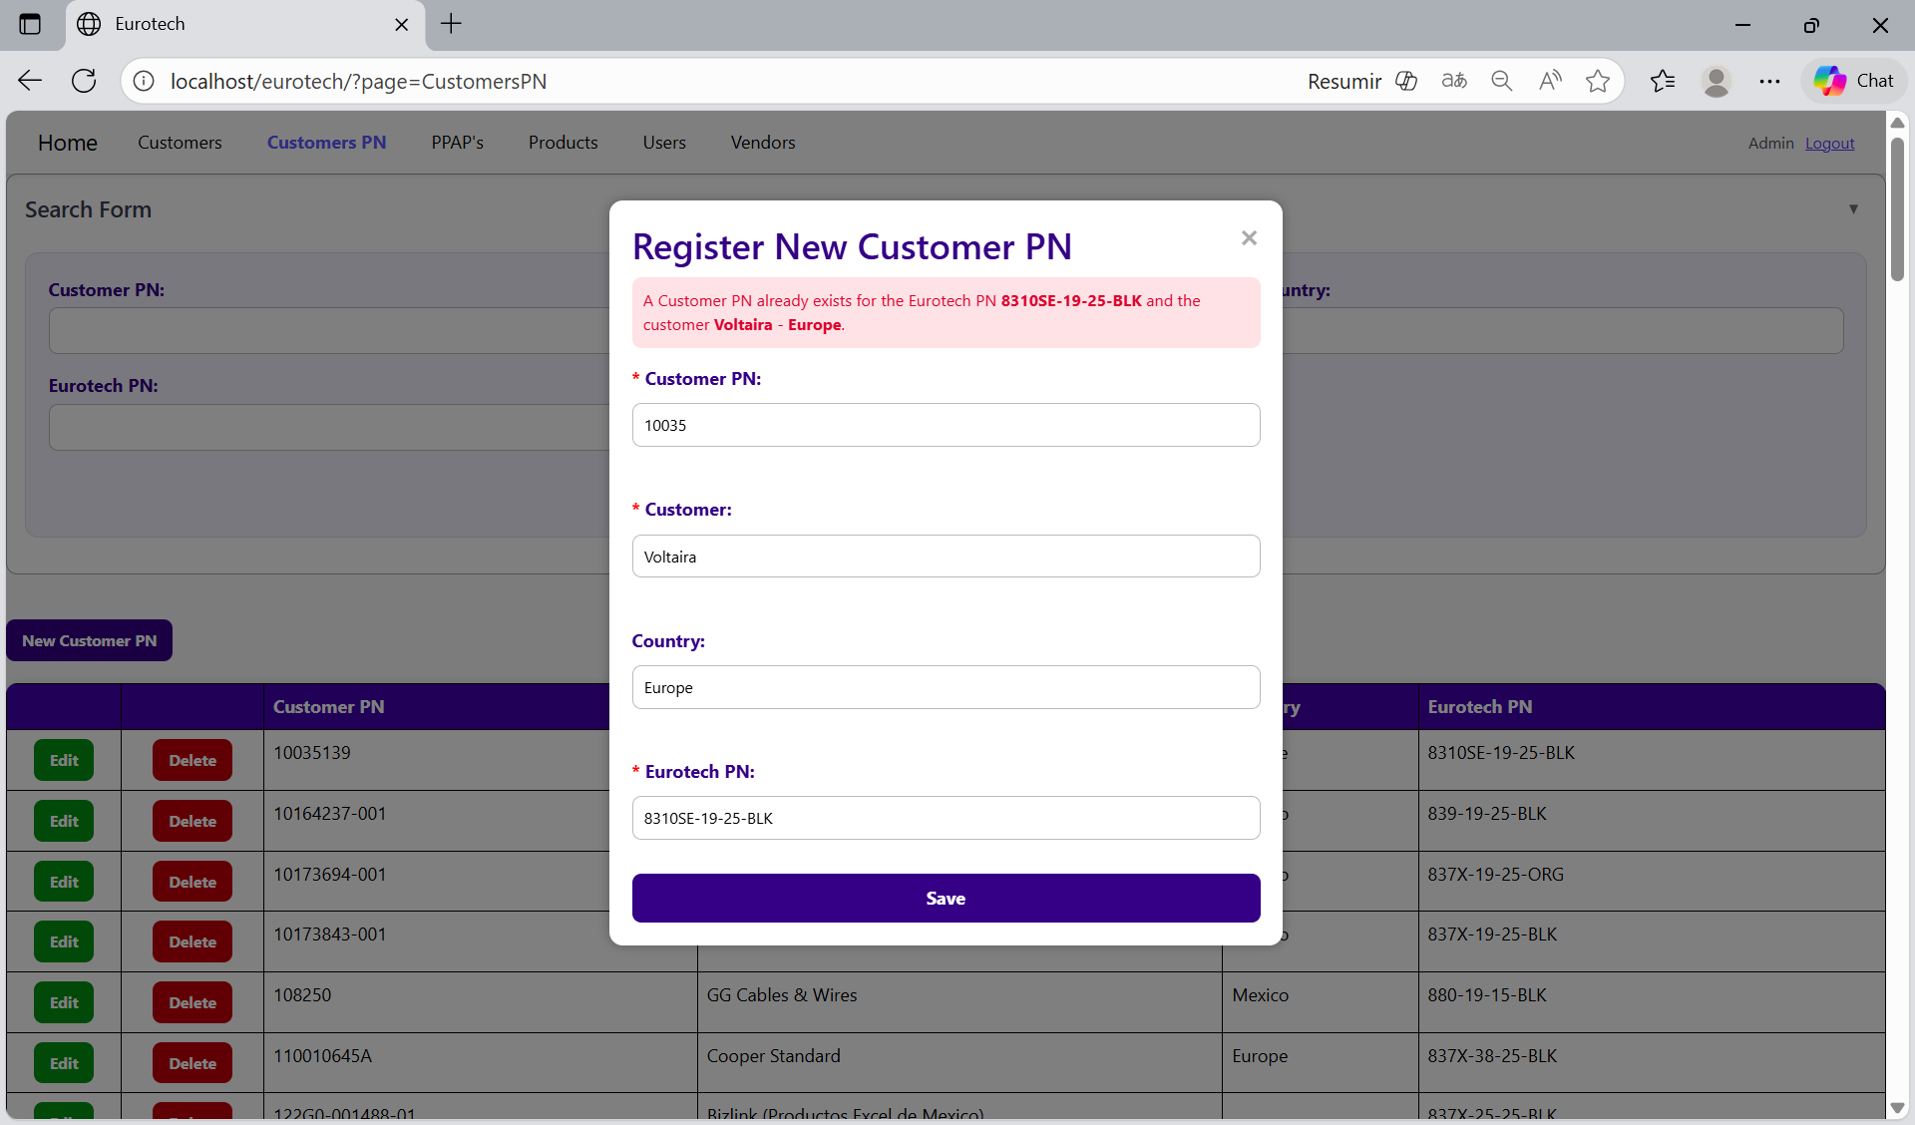

The error message prevents duplicate registers of Customers PN.

##### 3.11.2.1.5 A Customer PN already exists for the Eurotech PN *Eurotech PN* and the customer *name of the customer*.

If you try to duplicate a register with the same “Customer” and “Eurotech PN”, it will show an error message, that says that a Customer PN already exists for the Eurotech PN and customer’s name you are trying to register.

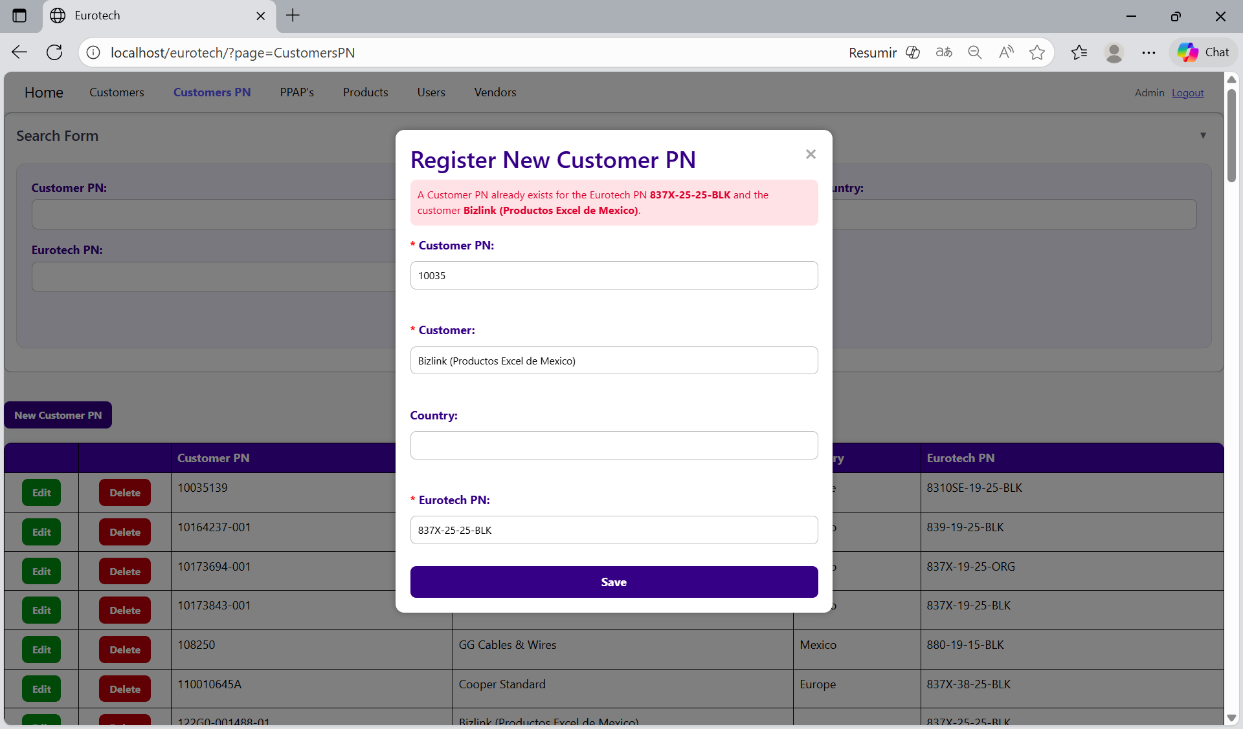

The error message prevents duplicate registers of Customers PN.

##### 3.11.2.1.6 You are duplicating the Customer PN *Customer PN* for the customer *name of the customer* - *country*.

If you try to duplicate a register with the same “Customer PN”, “Customer” and “Country”, it will show an error message, that says that a register already exists with the Customer PN, customer’s name and country you are trying to register.

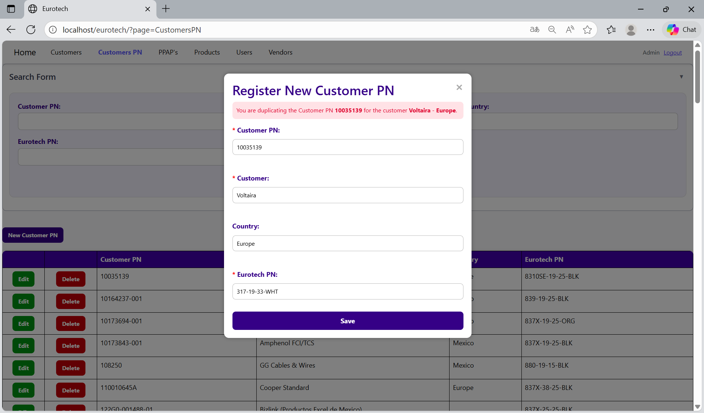

The error message prevents duplicate registers of Customers PN.

##### 3.11.2.1.7 You are duplicating the Customer PN *Customer PN* for the customer *name of the customer*.

If you try to duplicate a register with the same “Customer PN” and “Customer”, it will show an error message, that says that a register already exists with the Customer PN and customer’s name you are trying to register.

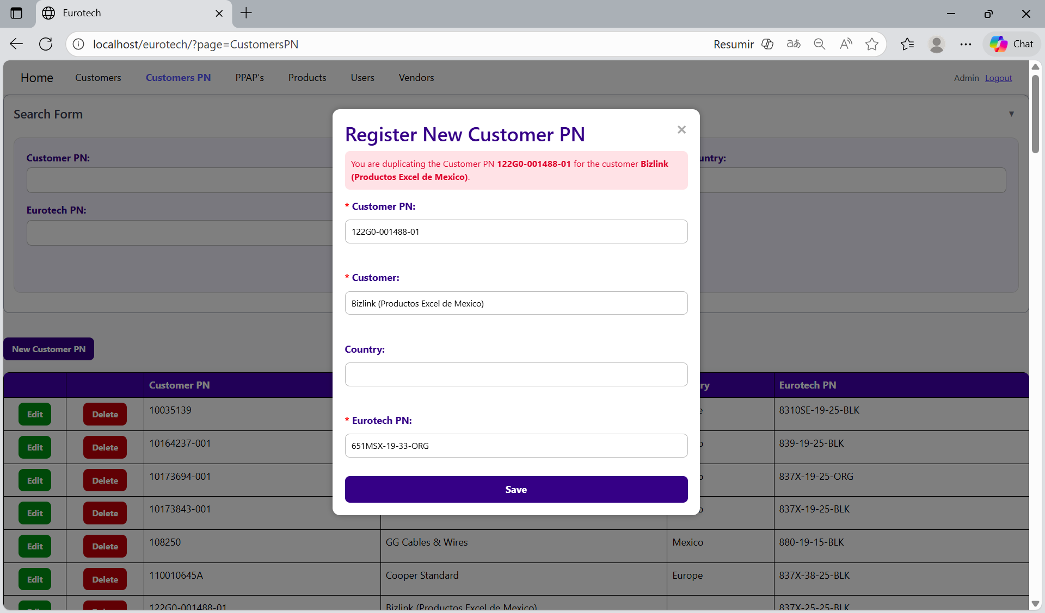

The error message prevents duplicate registers of Customers PN.

#### 3.11.2.2 Edit Form Errors.

##### 3.11.2.2.1 The customer *name of the customer* - *country* doesn’t exist.

If you write in the fields “Customer” and “Country” the data of a customer that doesn’t exist, it will show an error message, that says that doesn’t exist a register with the customer’s name and country you are trying to update.

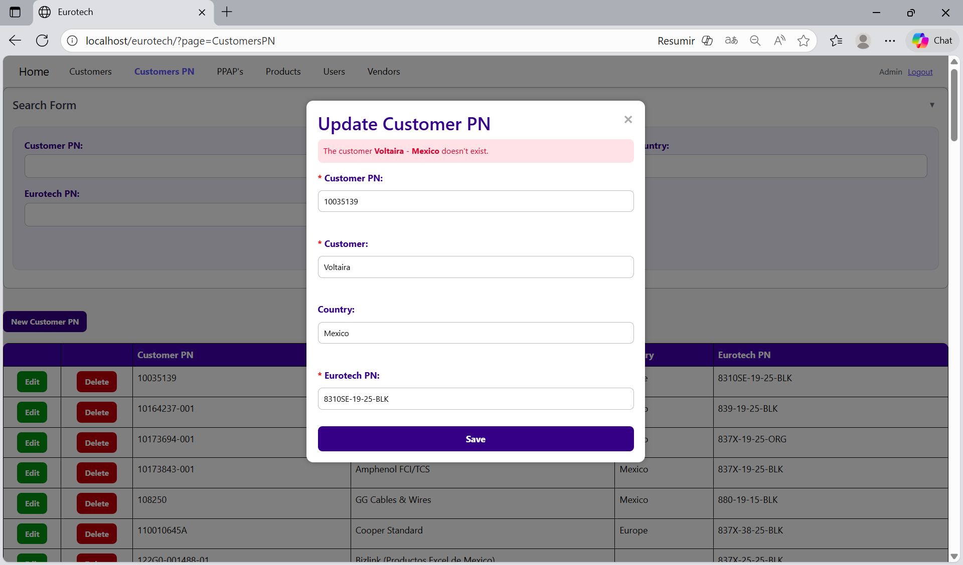

To correct this error, you must check first if the “Customer” and “Country” are written correctly. If they are written correctly but it keeps showing the same error message, then you must check in the “Customers” page if the register of the customer exists **(you can check in the Index the instruction *3.1.2 How to Search a Customer*).**

If the customer is not in the registers of the “Customers” page, then you must create a new register for that customer **(you can check in the Index the instruction *3.1.3 How to Add a New Customer*).**

Once you create the customer, you can now try to update the Customer PN again.

##### 3.11.2.2.2 The customer *name of the customer* doesn’t exist.

If you write in the “Customer” field and the “Country” field is empty, and the data doesn’t match with a register of a customer, it will show an error message, that says that doesn’t exist a register with the customer’s name you are trying to update.

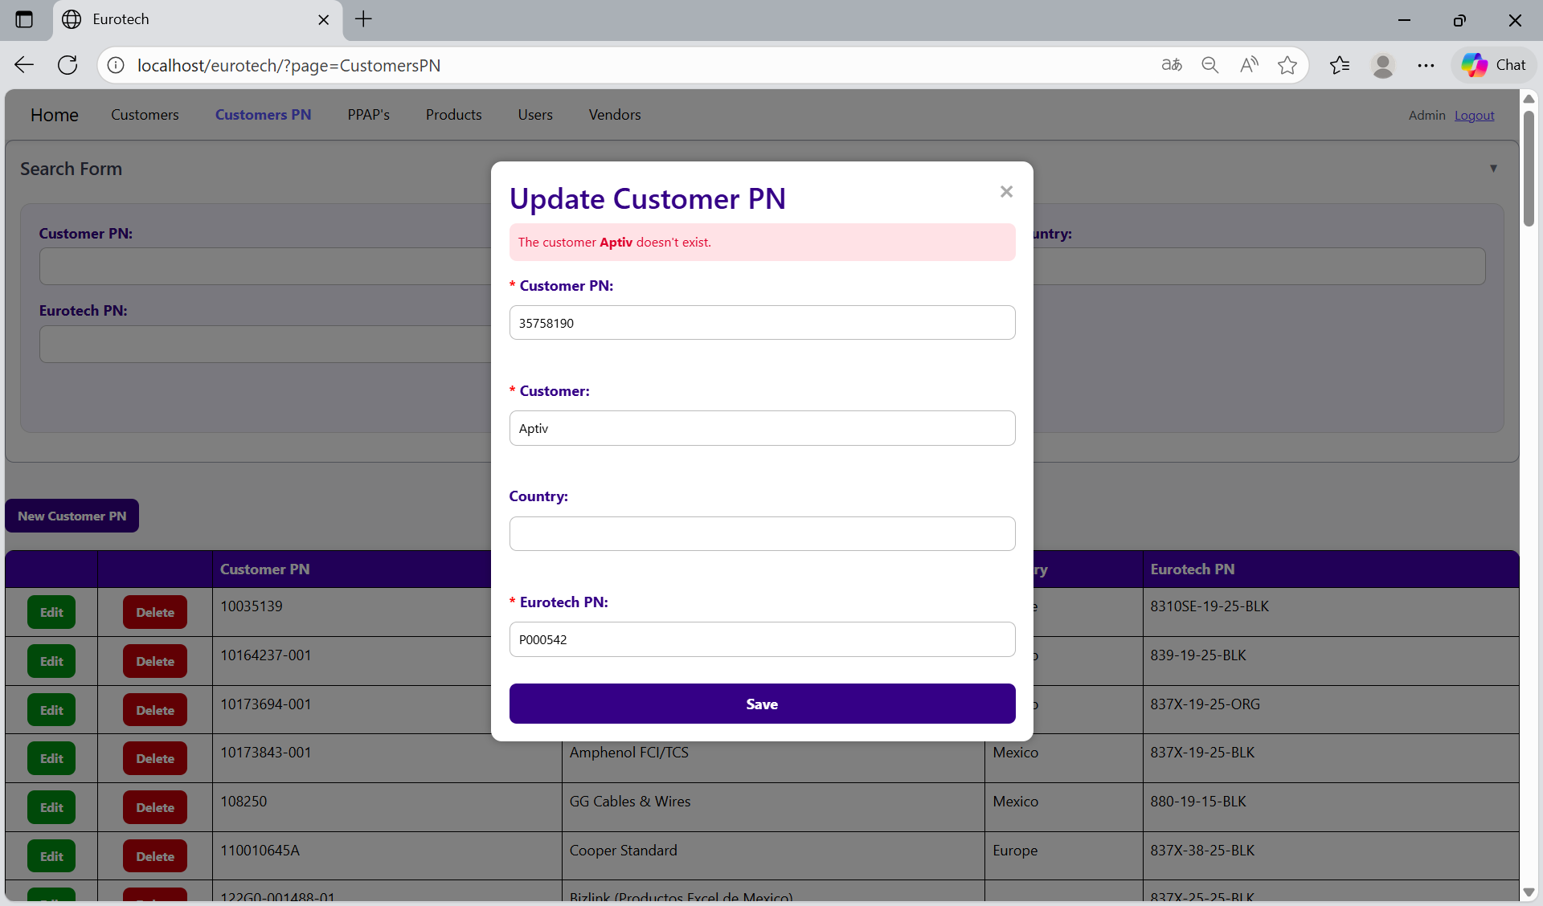

To correct this error, you must check first if the “Customer” is written correctly. If it is written correctly but it keeps showing the same error message, then you must check in the “Customers” page if the register of the customer exists **(you can check in the Index the instruction *3.1.2 How to Search a Customer*).**

If the customer is not in the registers of the “Customers” page, then you must create a new register for that customer **(you can check in the Index the instruction *3.1.3 How to Add a New Customer*).**

Once you create the customer, you can now try to update the Customer PN again.

##### 3.11.2.2.3 The Eurotech PN *Eurotech PN* doesn't exist.

If you write in the “Eurotech PN” field and the data doesn’t match with a register of a product of Eurotech, it will show an error message, that says that doesn’t exist a register with the Eurotech PN you are trying to update.

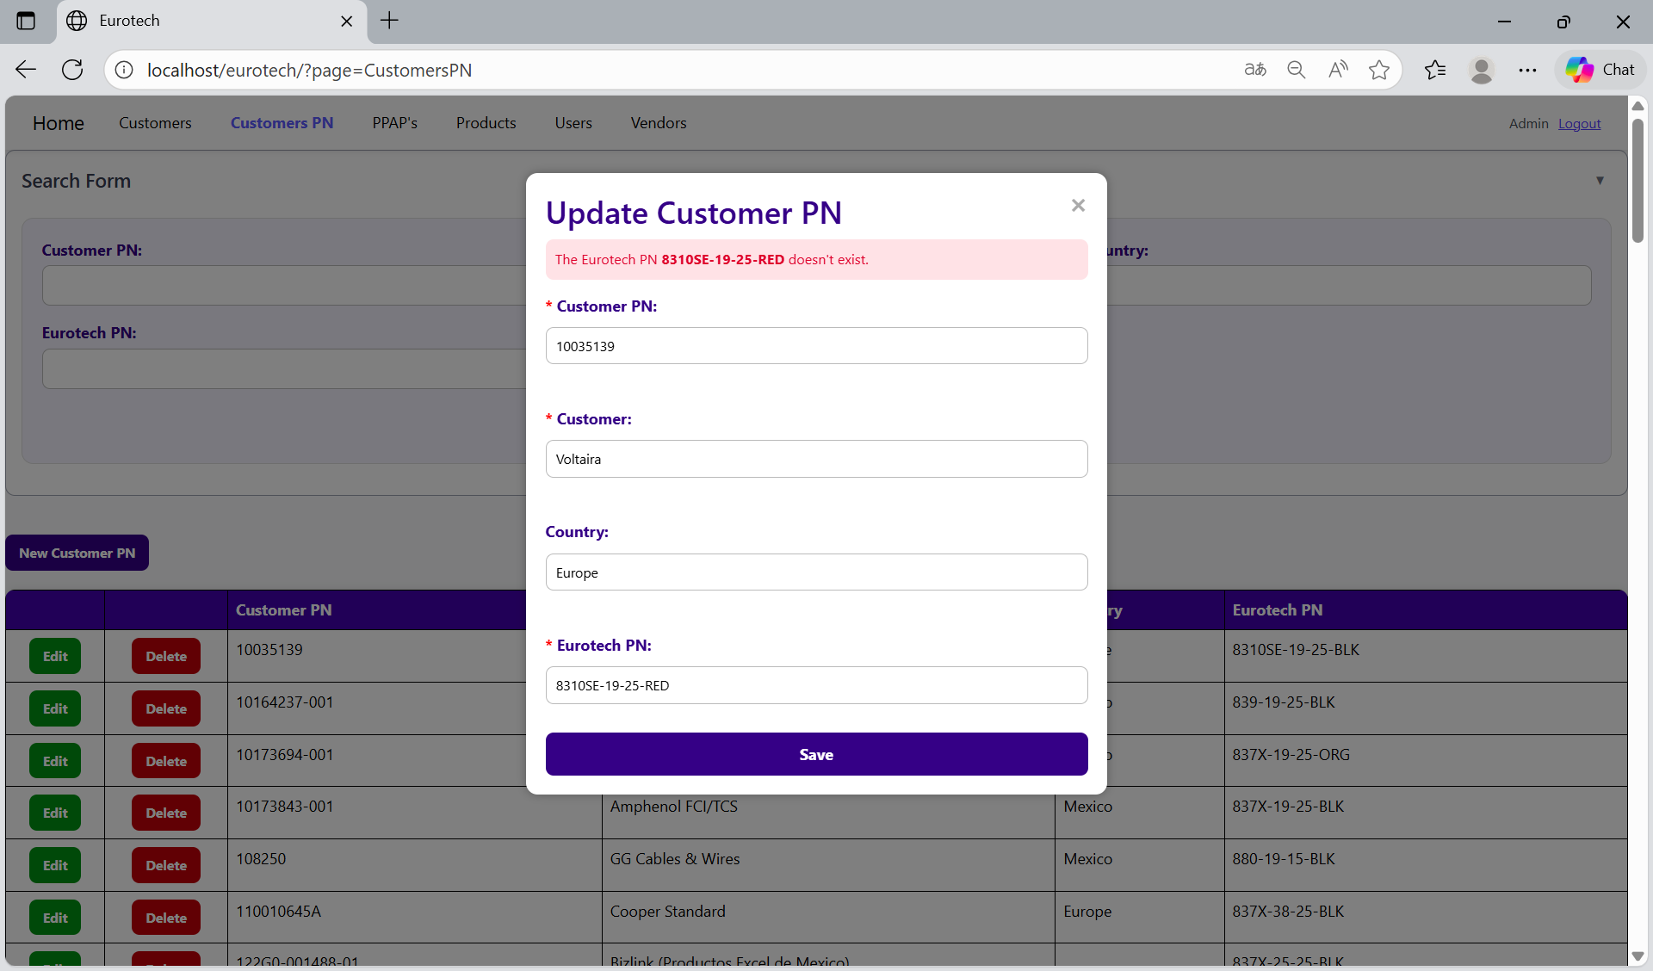

To correct this error, you must check first if the “Eurotech PN” is written correctly. If it is written correctly but it keeps showing the same error message, then you must check in the “Products” page if the register of the product exists **(you can check in the Index the instruction *3.8.2 How to Search a Product*).**

If the product is not in the registers of the “Products” page, then you must create a new register for that product **(you can check in the Index the instruction *3.8.3 How to Add a New Product*).**

Once you create the product, you can now try to update the Customer PN again.

##### 3.11.2.2.4 A Customer PN already exists for the Eurotech PN *Eurotech PN* and the customer *name of the customer* - *country*.

If you try to duplicate a register with the same “Customer”, “Country” and “Eurotech PN”, it will show an error message, that says that a Customer PN already exists for the Eurotech PN, customer’s name and country you are trying to update.

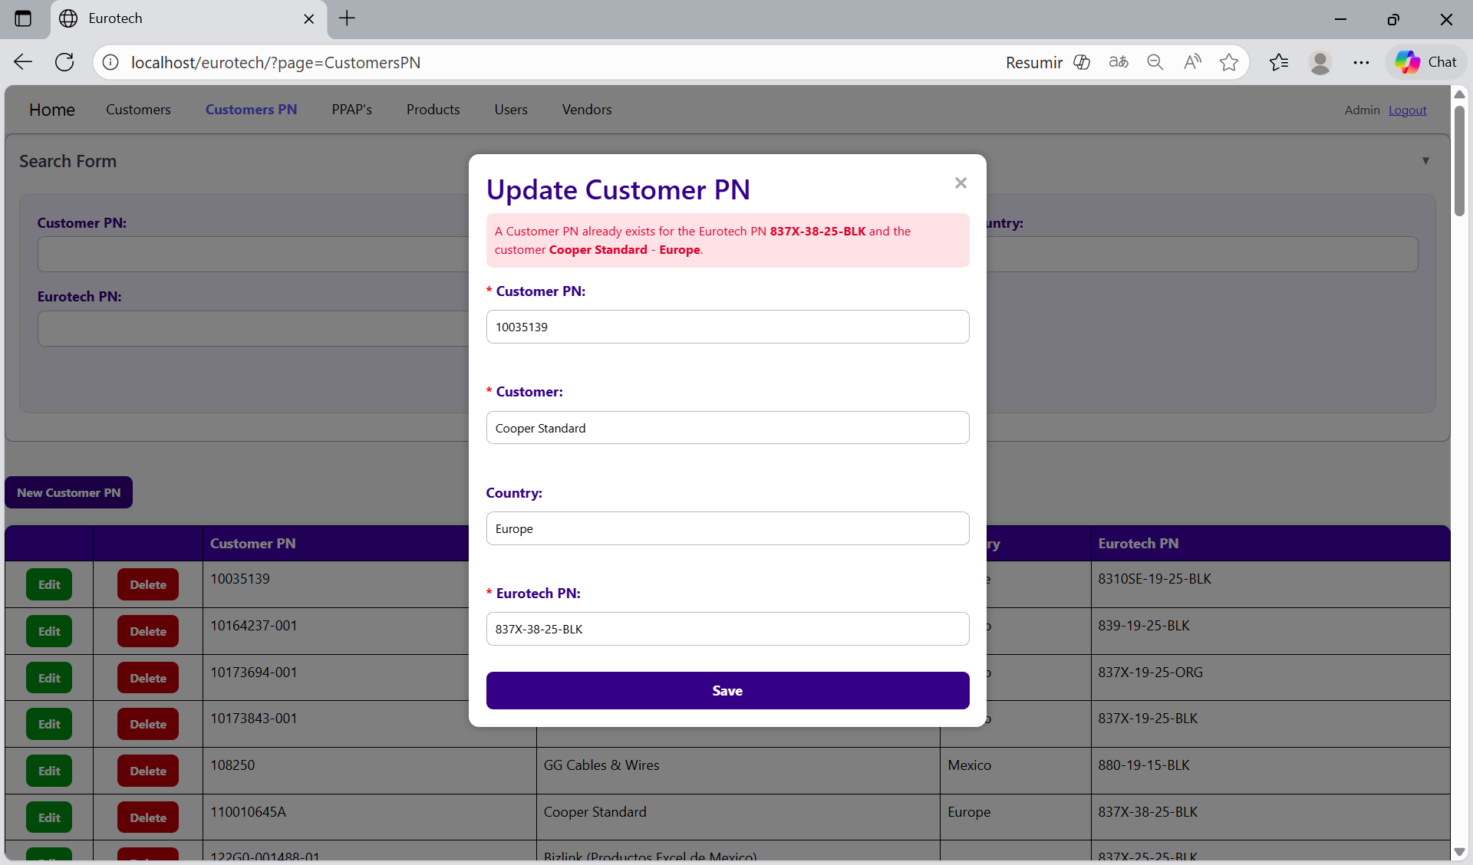

The error message prevents duplicate registers of Customers PN.

##### 3.11.2.2.5 A Customer PN already exists for the Eurotech PN *Eurotech PN* and the customer *name of the customer*.

If you try to duplicate a register with the same “Customer” and “Eurotech PN”, it will show an error message, that says that a Customer PN already exists for the Eurotech PN and customer’s name you are trying to update.

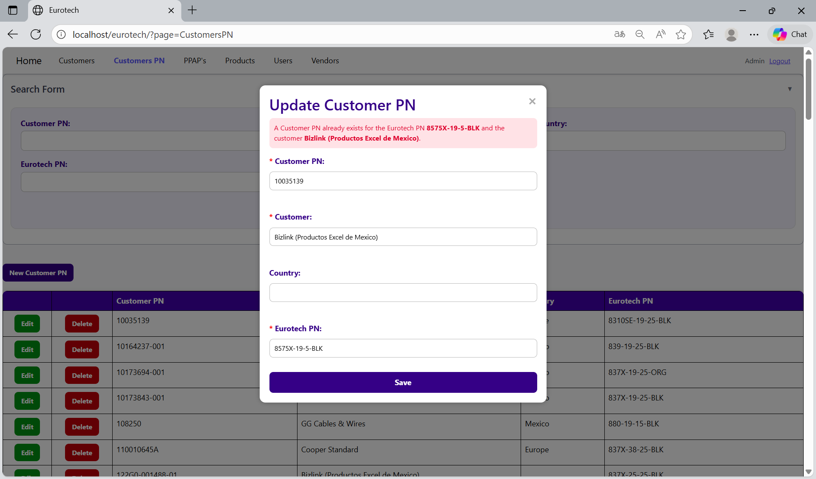

The error message prevents duplicate registers of Customers PN.

##### 3.11.2.2.6 You are duplicating the Customer PN *Customer PN* for the customer *name of the customer* - *country*.

If you try to duplicate a register with the same “Customer PN”, “Customer” and “Country”, it will show an error message, that says that a register already exists with the Customer PN, customer’s name and country you are trying to update.

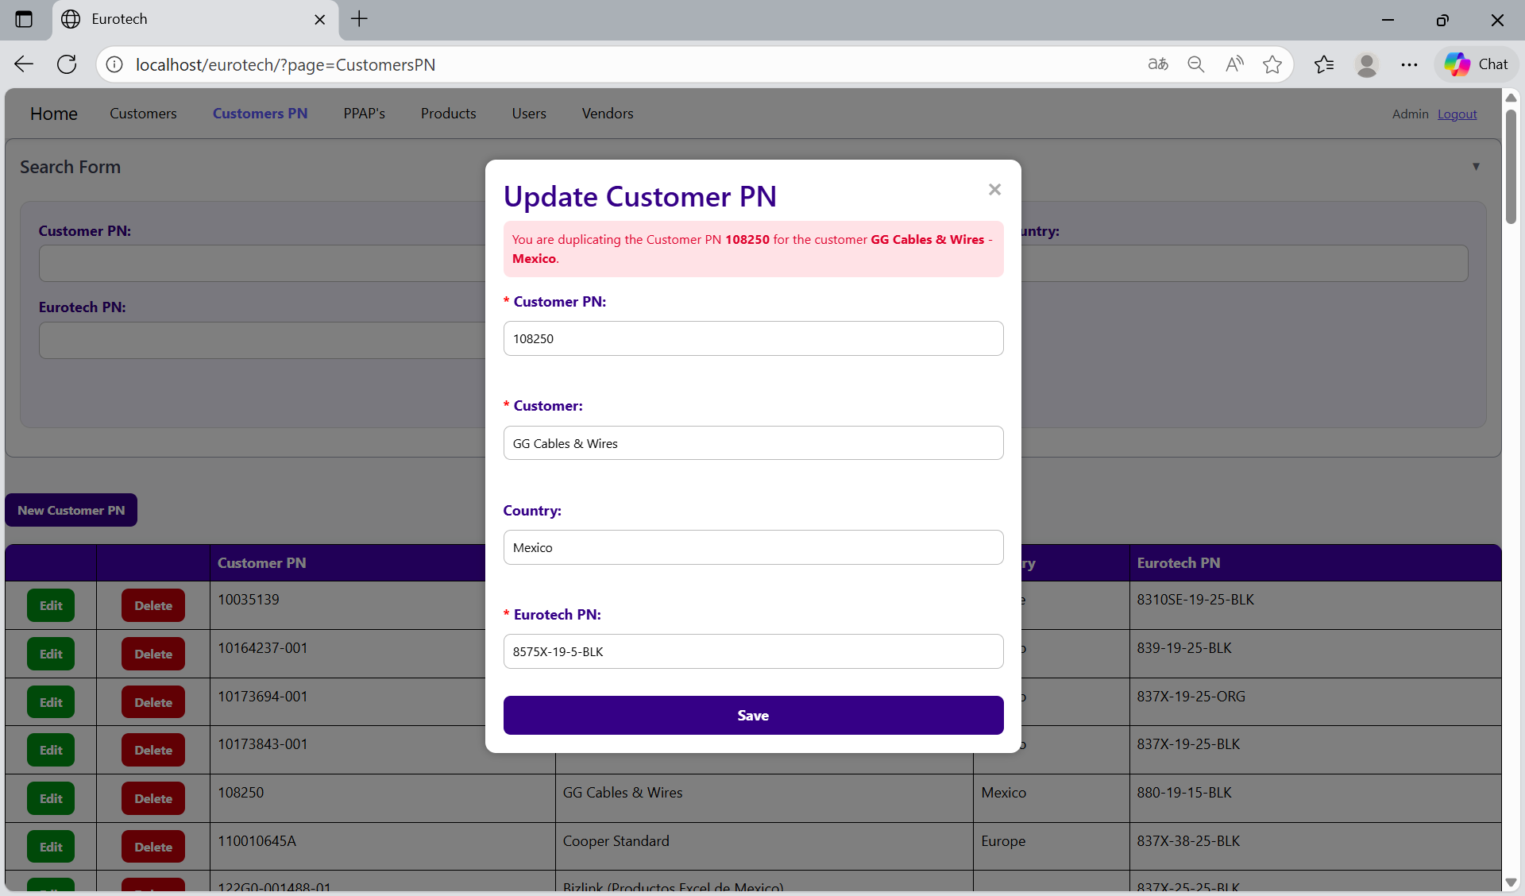

The error message prevents duplicate registers of Customers PN.

##### 3.11.2.2.7 You are duplicating the Customer PN *Customer PN* for the customer *name of the customer*.

If you try to duplicate a register with the same “Customer PN” and “Customer”, it will show an error message, that says that a register already exists with the Customer PN and customer’s name you are trying to update.

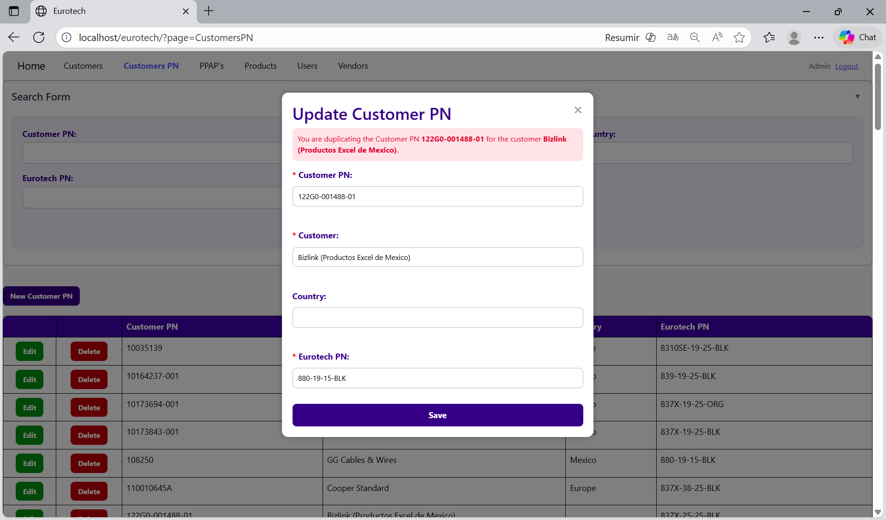

The error message prevents duplicate registers of Customers PN.

#### 3.11.2.3 Delete Form Errors.

##### 3.11.2.3.1 The customer PN can’t be deleted, because it already has registers.

If you tried to delete a Customer PN, and it shows you an error message, that says that the Customer PN you are trying to delete can’t be deleted, because it already has registers, this means that the Customer PN has registers in the “PPAP’s” page.

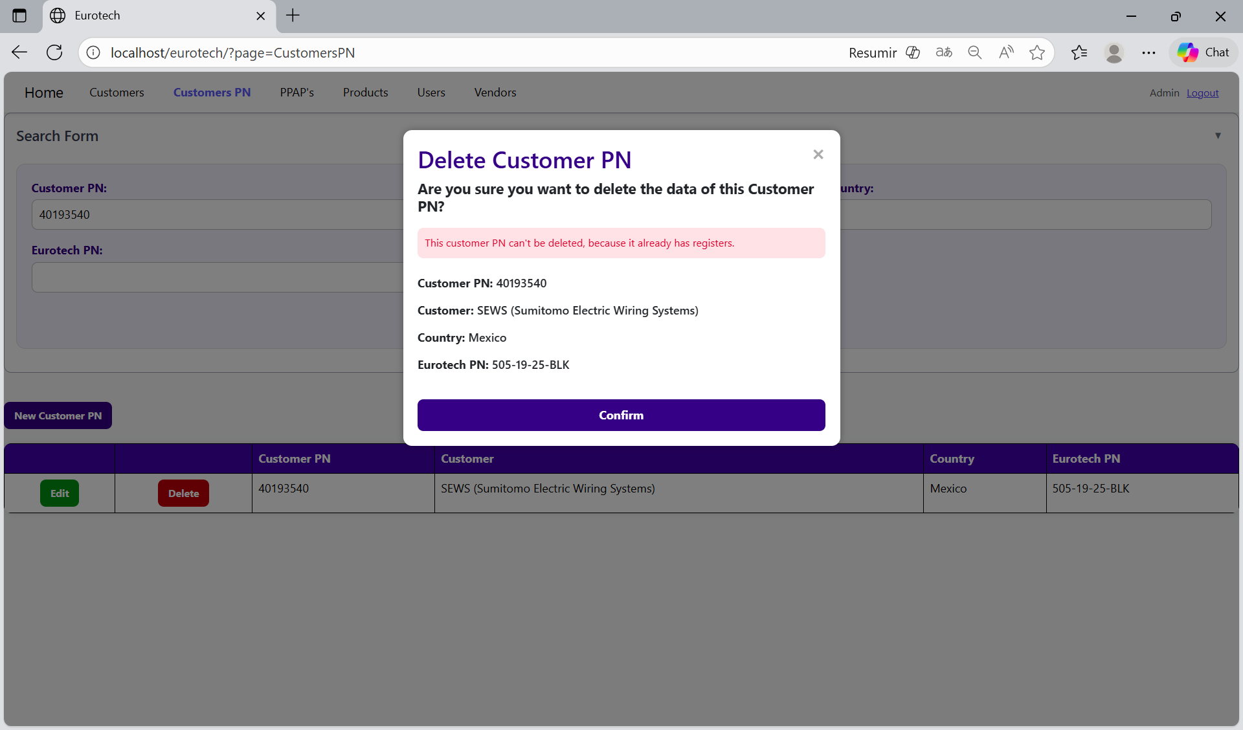

If you want to delete the Customer PN, you must delete all the registers of this Customer PN in the page “PPAP’s”.

### *3.11.3 PPAP’s Page Errors.*

#### 3.11.3.1 Register Form Errors.

#### 3.11.3.2 Edit Form Errors.

#### 3.11.3.3 Delete Form Errors.

### *3.11.4 BluSeal Page Errors.*

#### 3.11.4.1 Register Form Errors.

#### 3.11.4.2 Edit Form Errors.

#### 3.11.4.3 Delete Form Errors.

### *3.11.5 Cables Page Errors.*

#### 3.11.5.1 Register Form Errors.

#### 3.11.5.2 Edit Form Errors.

#### 3.11.5.3 Delete Form Errors.

### *3.11.6 Tapes Page Errors.*

#### 3.11.6.1 Register Form Errors.

#### 3.11.6.2 Edit Form Errors.

#### 3.11.6.3 Delete Form Errors.

### *3.11.7 Tubes Page Errors.*

#### 3.11.7.1 Register Form Errors.

#### 3.11.7.2 Edit Form Errors.

#### 3.11.7.3 Delete Form Errors.

### *3.11.8 Products Page Errors.*

#### 3.11.8.1 Register Form Errors.

##### 3.11.8.1.1 The Eurotech PN *Eurotech PN* already exists.

If you write a Eurotech PN that already exists, it will show an error message, that says that exists a register with the Eurotech PN you are trying to register.

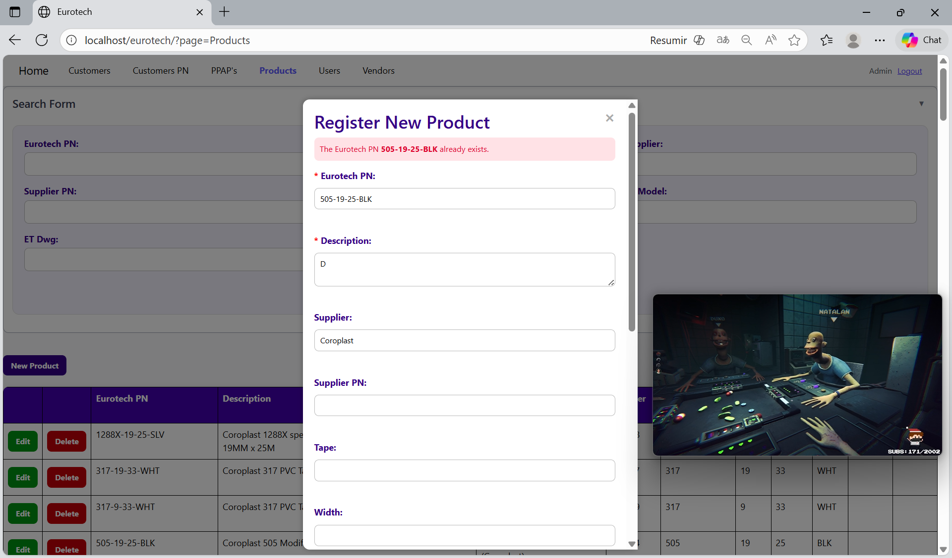

The error message prevents duplicate registers of products.

##### 3.11.8.1.2 The description *description* already exists.

If you write a Supplier PN that already exists, it will show an error message, that says that exists a register with the Supplier PN you are trying to register.

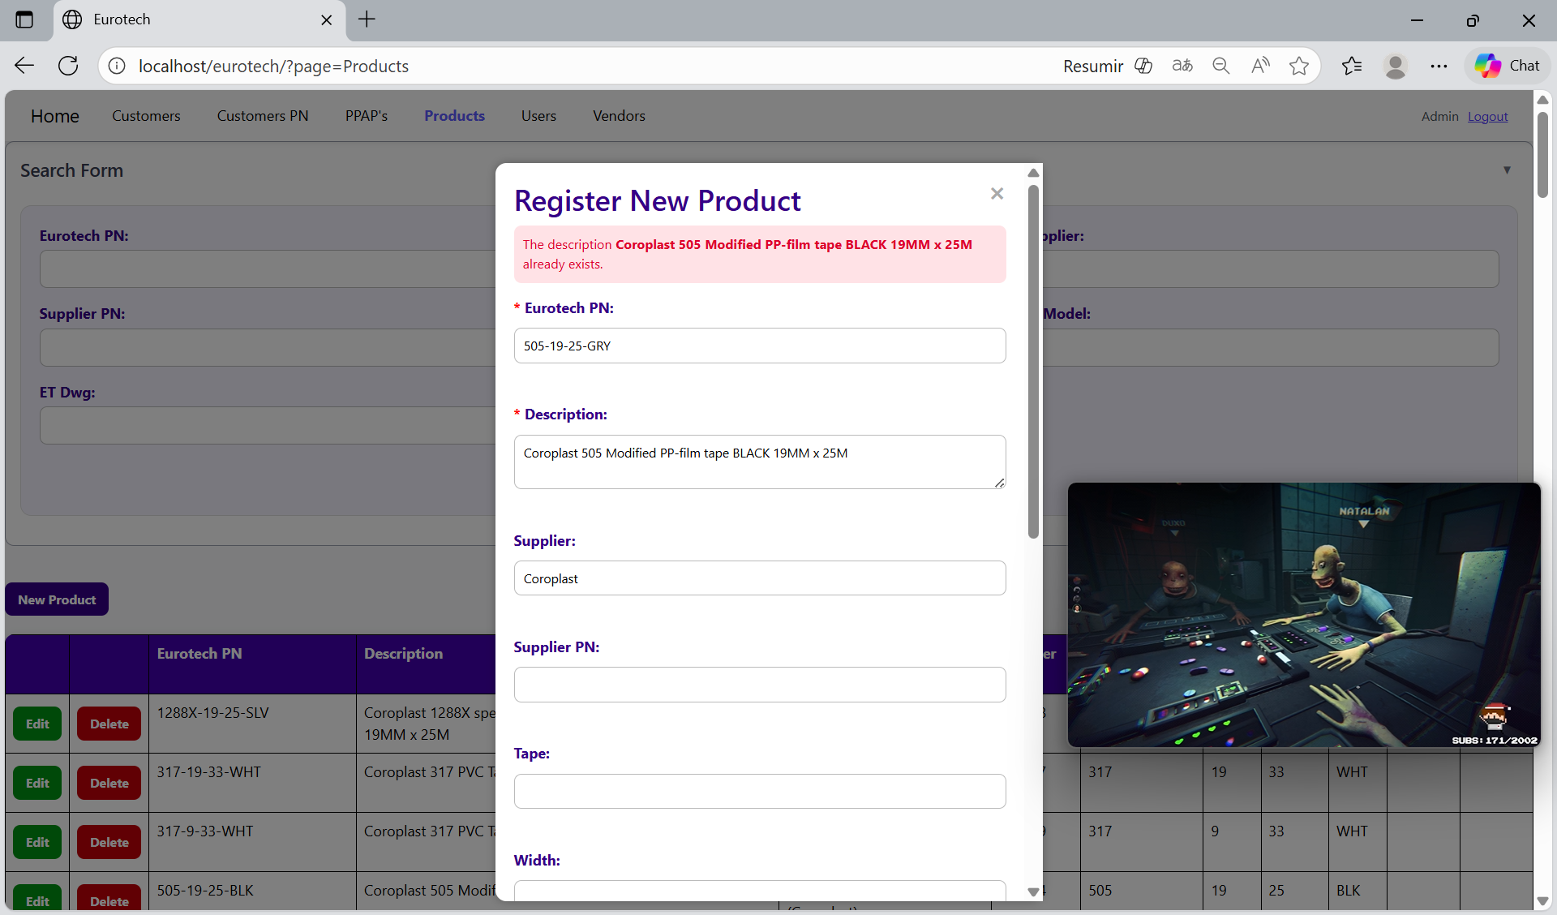

The error message prevents duplicate registers of products.

##### 3.11.8.1.3 The Supplier PN *Supplier PN* already exists.

If you write a Supplier PN that already exists, it will show an error message, that says that exists a register with the Supplier PN you are trying to register.

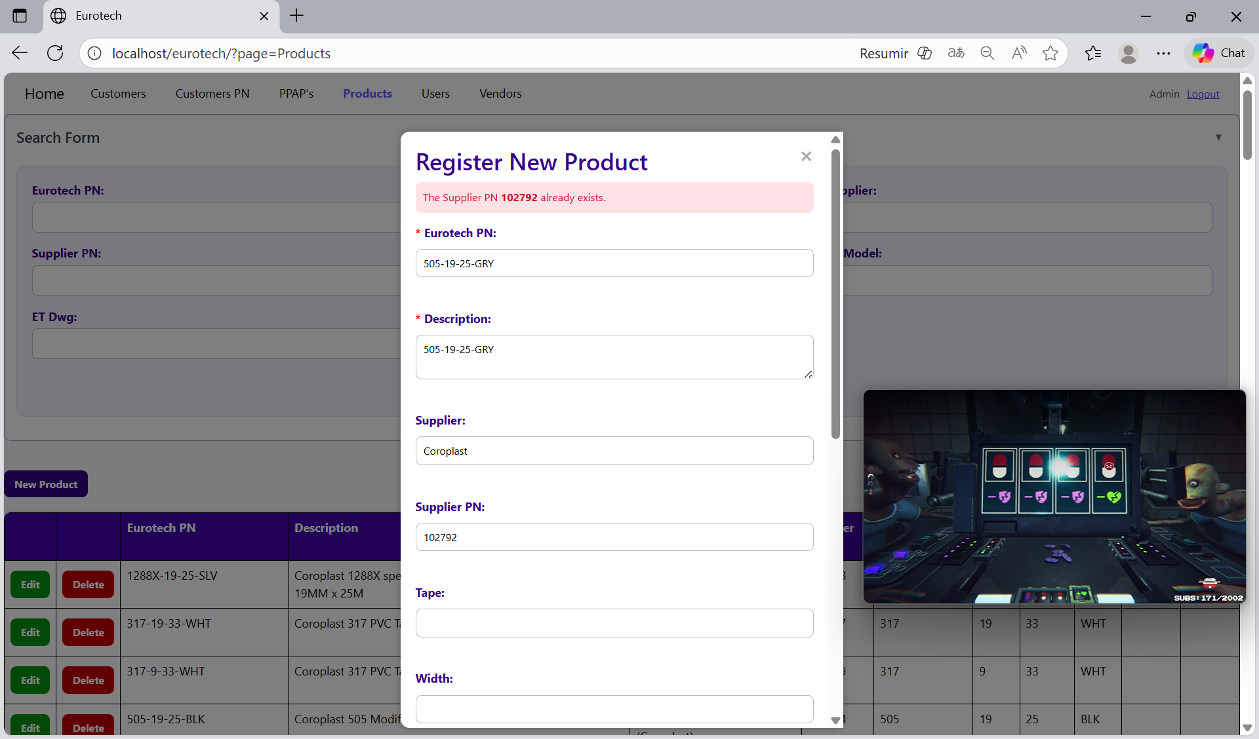

The error message prevents duplicate registers of products.

##### 3.11.8.1.4 The Eurotech PN *Eurotech PN* and the description *description* already exist.

If you write a Eurotech PN and a description that already exist, it will show an error message, that says that exists a register with the Eurotech PN and description you are trying to register.

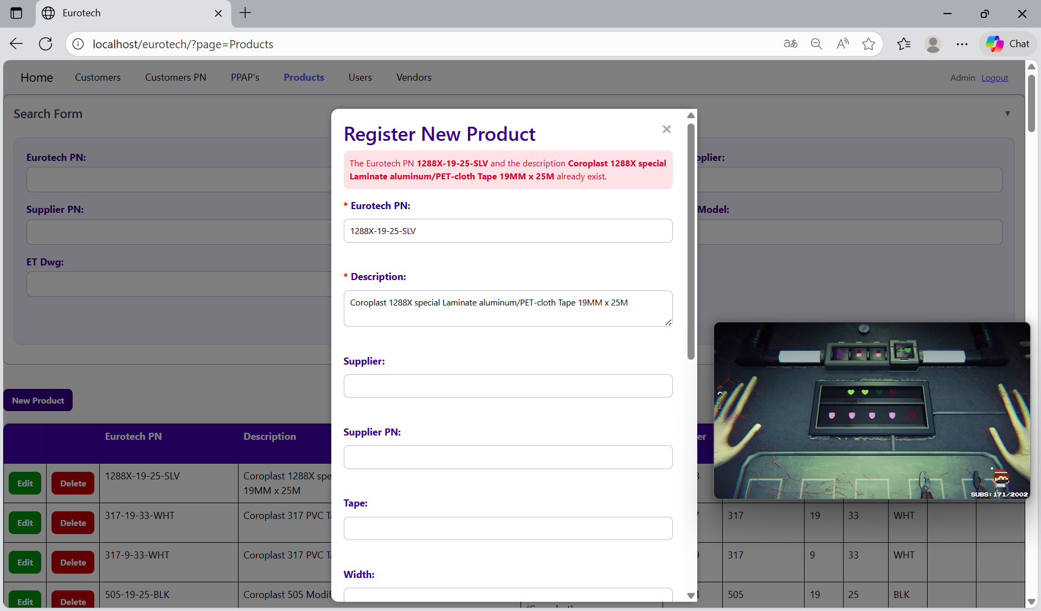

The error message prevents duplicate registers of products.

##### 3.11.8.1.5 The Eurotech PN *Eurotech PN* and the Supplier PN *Supplier PN* already exist.

If you write a Eurotech PN and a Supplier PN that already exist, it will show an error message, that says that exists a register with the Eurotech PN and Supplier PN you are trying to register.

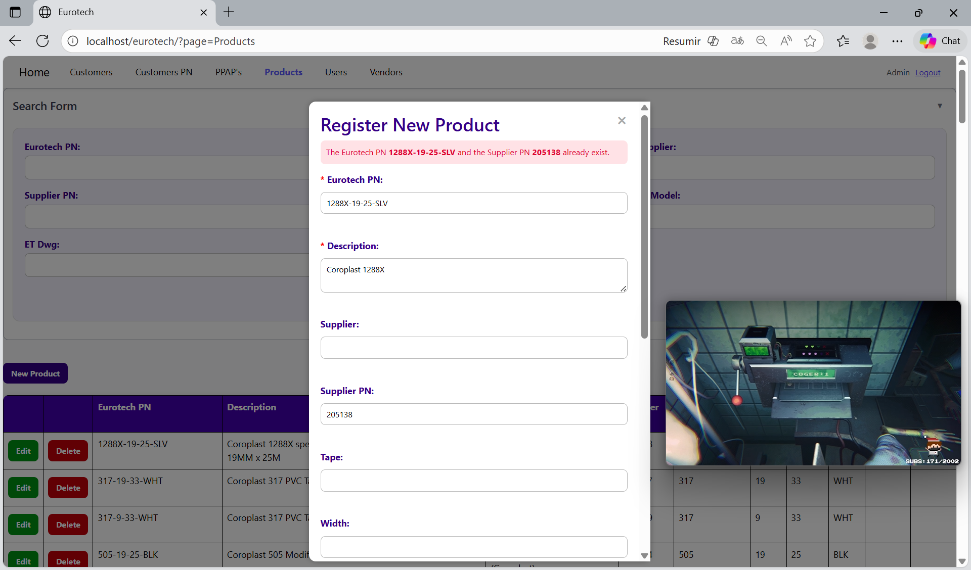

The error message prevents duplicate registers of products.

##### 3.11.8.1.6 The Supplier PN *Supplier PN* and the description *description* already exist.

If you write a Supplier PN and a description that already exist, it will show an error message, that says that exists a register with the Supplier PN and description you are trying to register.

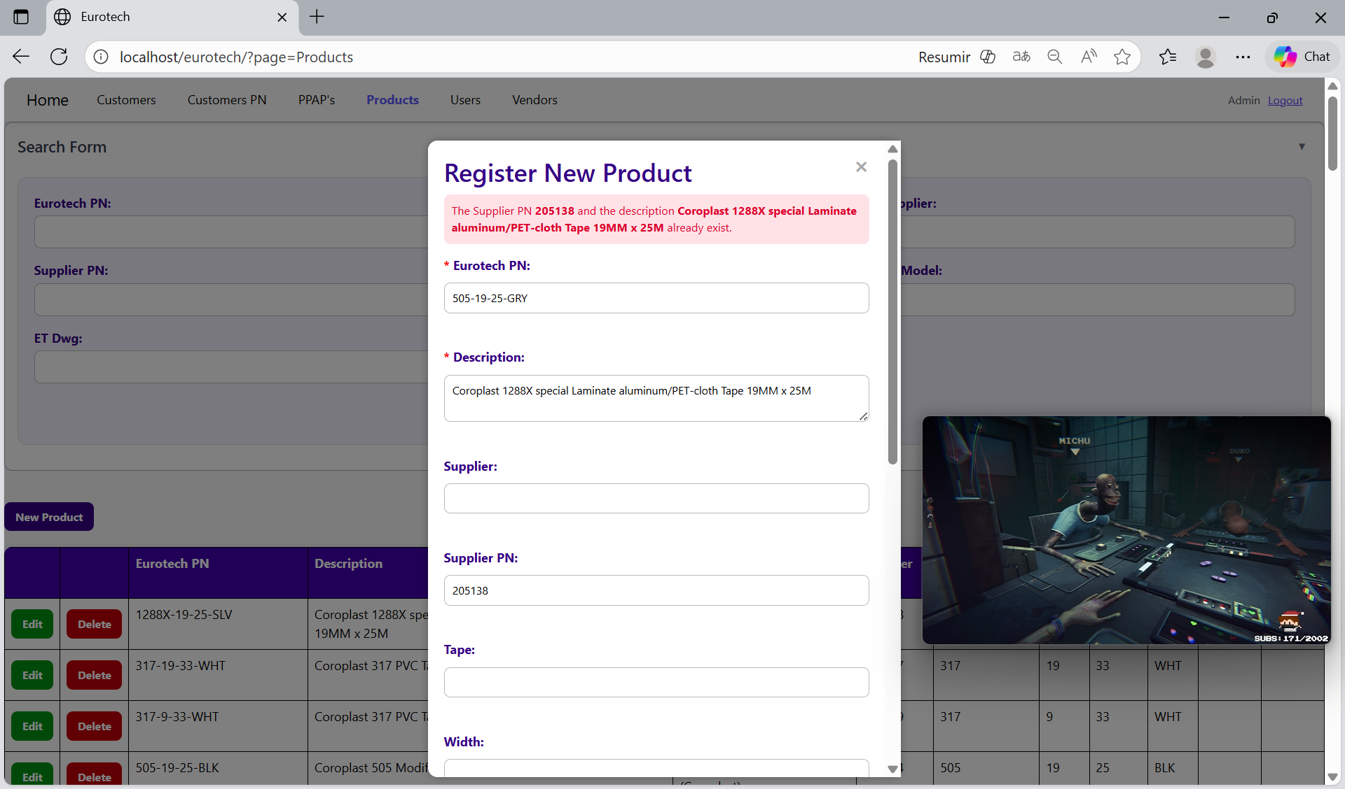

The error message prevents duplicate registers of products.

##### 3.11.8.1.7 The Eurotech PN *Eurotech PN*, the Supplier PN *Supplier PN* and the description *description* already exist.

If you write a Eurotech PN, a Supplier PN and a description that already exist, it will show an error message, that says that exists a register with the Eurotech PN, Supplier PN and description you are trying to register.

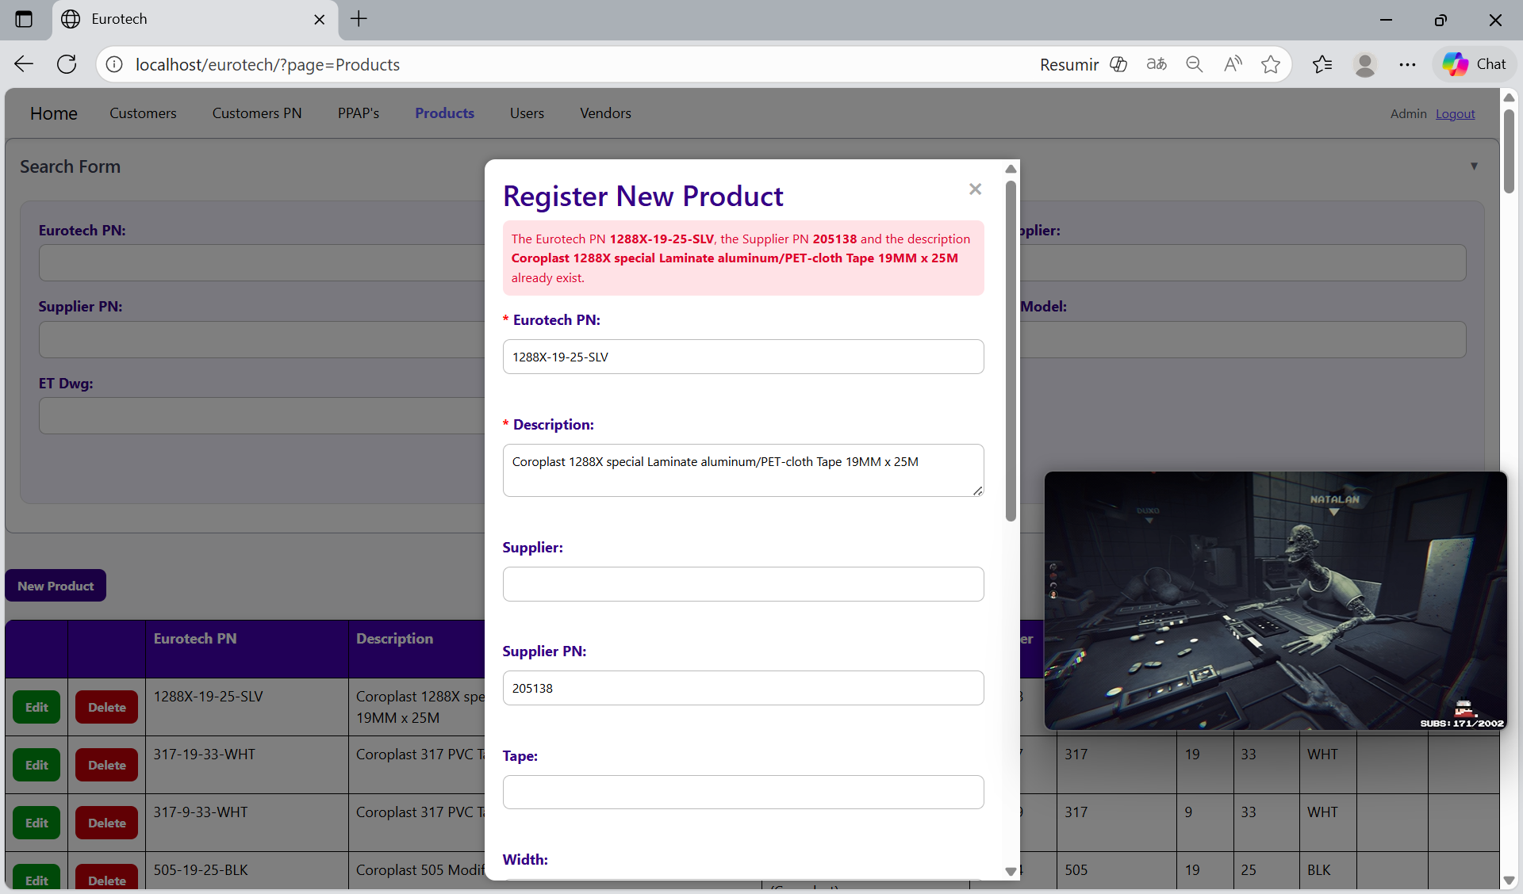

The error message prevents duplicate registers of products.

#### 3.11.8.2 Edit Form Errors.

#### 3.11.8.3 Delete Form Errors.

### *3.11.9 Users Page Errors.*

#### 3.11.9.1 Register Form Errors.

#### 3.11.9.2 Edit Form Errors.

#### 3.11.9.3 Delete Form Errors.

### *3.11.10 Vendors Page Errors.*

#### 3.11.10.1 Register Form Errors.

#### 3.11.10.2 Edit Form Errors.

#### 3.11.10.3 Delete Form Errors.

# **4. Users with the role “User”**

## ***4.1 PPAP’s Page***

### *4.1.1 How to Navigate to “PPAP’s” Page.*

### *4.1.2 How to Search a PPAP.*

### *4.1.3 How to Export the Information of the Table to an Excel Document.*

## ***4.2 BluSeal Page***

### *4.2.1 How to Navigate to “BluSeal” Page.*

### *4.2.2 How to Search a PPAP.*

### *4.2.3 How to Export the Information of the Table to an Excel Document.*

## ***4.3 Cables Page***

### *4.3.1 How to Navigate to “Cables” Page.*

### *4.3.2 How to Search a PPAP.*

### *4.3.3 How to Export the Information of the Table to an Excel Document.*

## ***4.4 Tapes Page***

### *4.4.1 How to Navigate to “Tapes” Page.*

### *4.4.2 How to Search a PPAP.*

### *4.4.3 How to Export the Information of the Table to an Excel Document.*

## ***4.5 Tubes Page***

### *4.5.1 How to Navigate to “Tubes” Page.*

### *4.5.2 How to Search a PPAP.*

### *4.5.3 How to Export the Information of the Table to an Excel Document.*